Retail Management Application Using Salesforce (DEVELOPER)

**Category: Salesforce Developer**

**Skills Required:**Salesforce Admin

**Project Description:**

Retailing encompasses the business activities involved in selling goods and services to consumers for their personal, family, or household etc. A CRM product owner has requested to create two applications, one is a sales app for sales reps to use this application and store customers data, and the second application is a service app for service reps/agents to provide support to customers in dealing cases. To generate business on top of the customers.

Introduction & Creation Salesforce Org

Are you new to Salesforce? Not sure exactly what it is, or how to use it? Don’t know where you should start on your learning journey? If you’ve answered yes to any of these questions, then you’re in the right place. This module is for you.

Welcome to Salesforce! Salesforce is game-changing technology, with a host of productivity-boosting features, that will help you sell smarter and faster. As you work toward your badge for this module, we’ll take you through these features and answer the question, “What is Salesforce, anyway?”

**What Is Salesforce?**

Salesforce is your customer success platform, designed to help you sell, service, market, analyze, and connect with your customers.

Salesforce has everything you need to run your business from anywhere. Using standard Products and features, you can manage relationships with prospects and customers, collaborate and engage with employees and partners, and store your data securely in the cloud.

So what does that really mean? Well, before Salesforce, your Contacts, emails, follow- uptasks, and prospective deals might have been organized something like this:

<https://youtu.be/r9EX3lGde5k>

**Creating Developer Org**

Duration: 1 Hrs

Skill Tags:

Creating a developer org in salesforce.

1. Go to developers.salesforce.com/Signup
2. Click on sign up.
3. On the sign up form, enter the following details :
   1. First name & Last name
   2. Email
   3. Role : Developer
   4. Company : College Name
   5. County : India
   6. Postal Code : pin code
   7. Username : should be a combination of your name and company This need not be an actual email id, you can give anything in the format: username@organization.com

Click on sign up after filling this

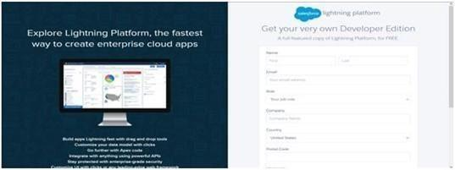

Account Activation

Go to the inbox of the email that you used while signing up. Click on the verify account to activate your account. The email may take 5-10mins, as

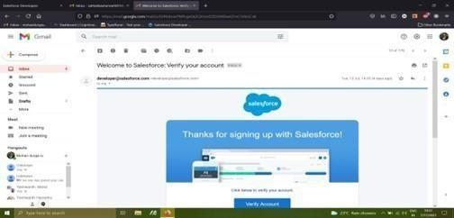

Login to your Salesforce Org

1. Go to salesforce.com and click on login.
2. Enter the username and password that you just created.
3. After login this is the home page which you will see.

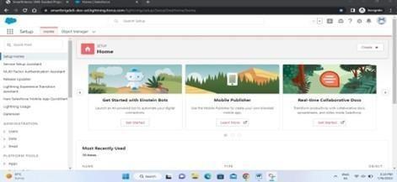

*Salesforce Login:*  
https://login.salesforce.com

**Object**

Objects are database table that permit you to store data that is specific to an organization. Salesforce objects are of two types: 1) Standard objects, 2) Custom objects.

1. Standard Objects: Standard objects are the kind of objects that are provided by salesforce.com such as users, contracts, reports, dashboards, etc.
2. Custom Objects: Custom objects are those objects that are created by users. They supply information that is unique and essential to their organization. They are the heart of any application and provide a structure for sharing data.

Objects involved in retail management are:

|  |  |  |
| --- | --- | --- |
| **Application** | **Object** | **Description** |
| Sales app | Campaign | We do promotions by using this object |
| Lead | We capture leads here |
| Account | We capture customers data |
| Contact | Employees data of customer |
| Opportunity | SMB sales orders data |
| Product | Here we store product details i.e electronic types |
| Warehouse | We capture stocks data |
| Sales order | This is an actual order which has invoice details |
| Dispatch/Tracking | Orders dispatch related info will be stored here |
| Service app | Case | Historical problems of customers will be stored here |
| Account | We captures customers data |

We need to create these objects -

1. Warehouse
2. Sales order
3. Dispatch/Tracking

**Creation Of Warehouse Object**

1. Click on the gear icon and then select Setup.
2. Click on the object manager tab just beside the home tab.
3. After the above steps, have a look on the extreme right you will find a Create Dropdown click on that and select Custom Object.
4. On the Custom Object Definition page, create the object as follows:
5. Label: Warehouse
6. Plural Label: Warehouses
7. Record Name: Warehouse Name
8. Check the Allow Reports checkbox
9. Check the Allow Search checkbox
10. Click Save.

In the same way create **2** more objects as Sales order, Dispatch/Tracking.  
**Note**– While making **Sales order** Object select data type “A**uto Number**” & Record Name- “Sales order Number” in “Enter Record Name Label and Format” Section.

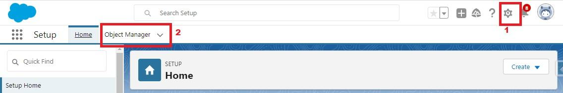

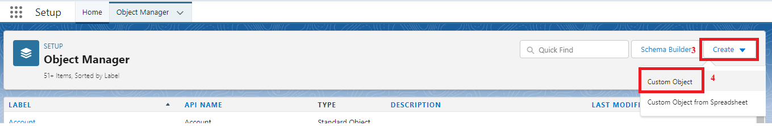

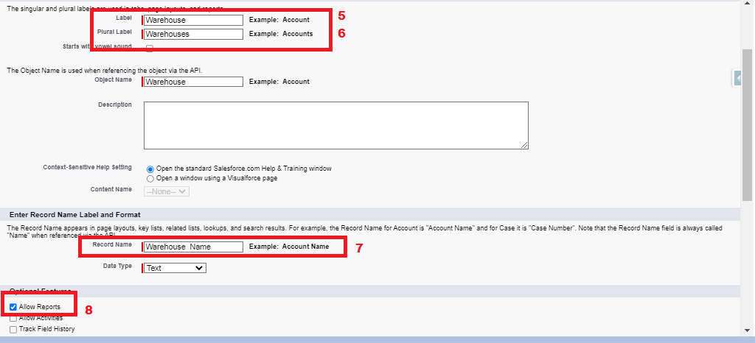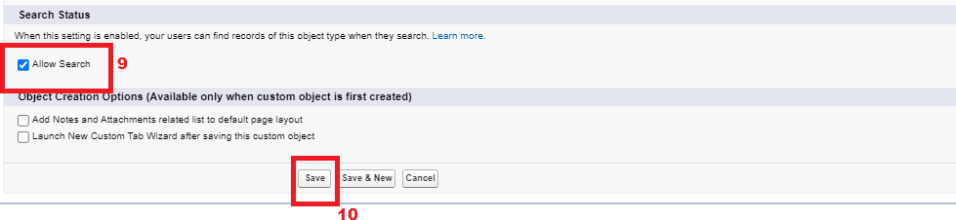

**What Is A Tab?**

Tabs in Salesforce help users view the information at a glance. It displays the data of objects and other web content in the application.

There are mainly 4 types of tabs:

1. Standard Object Tabs: Standard object tabs display data related to standard objects
2. Custom Object Tabs: Custom object tabs displays data related to custom objects.
3. Web Tabs: Web Tabs display any external Web-based application or Web page in a Salesforce tabs.
4. Visualforce Tabs: Visualforce Tabs display data from a Visualforce Page.

### Create A Tab For Warehouse Object

Now create a custom tab. Click the Home tab.

1. Enter Tabs in Quick Find and select Tabs.
2. Under Custom Object Tabs, click New.
3. For Object, select Warehouse.
4. For Tab Style, select any icon.
5. Leave all defaults as is. Click Next, Next, and Save
6. In the same way create Tabs for all Custom Objects – Sales order, Dispatch /Tracking.

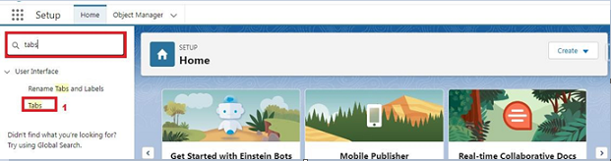

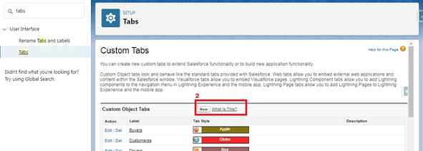

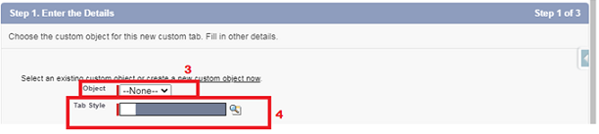

**Note: The description, Logo, and Label of standard app cannot be altered.**

**What Is An App**

**Custom Apps**: Custom apps are created according to need of user. Custom Apps are made by using standard and custom tabs together.

**Note: Logos for Custom Apps can be changed.**

**Create The Sales App**

1. From Setup, enter App Manager in the Quick Find and select App Manager.
2. Click New Lightning App.
3. Enter Sales App as the App Name, then click Next
4. Under App Options, leave the default selections and click Next.
5. Under Utility Items, leave as is and click Next.
6. From Available Items, select Campaign, Leads, Accounts, Contacts, Opportunities, Products, Warehouse, Sales order, Dispatch/Tracking, Reports, and Dashboards and move them to Selected Items. Click Next.
7. From Available Profiles, select System Administrator and move it to Selected Profiles.Click Save & Finish.

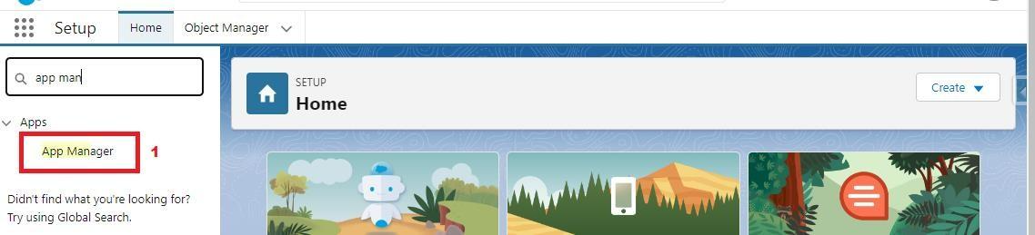

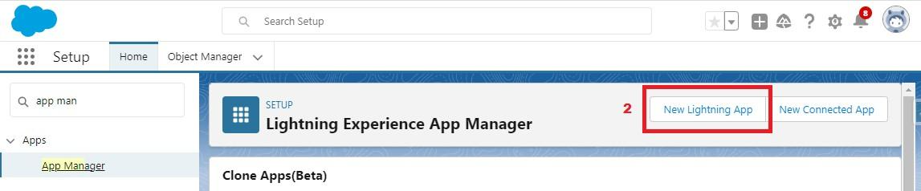  
  
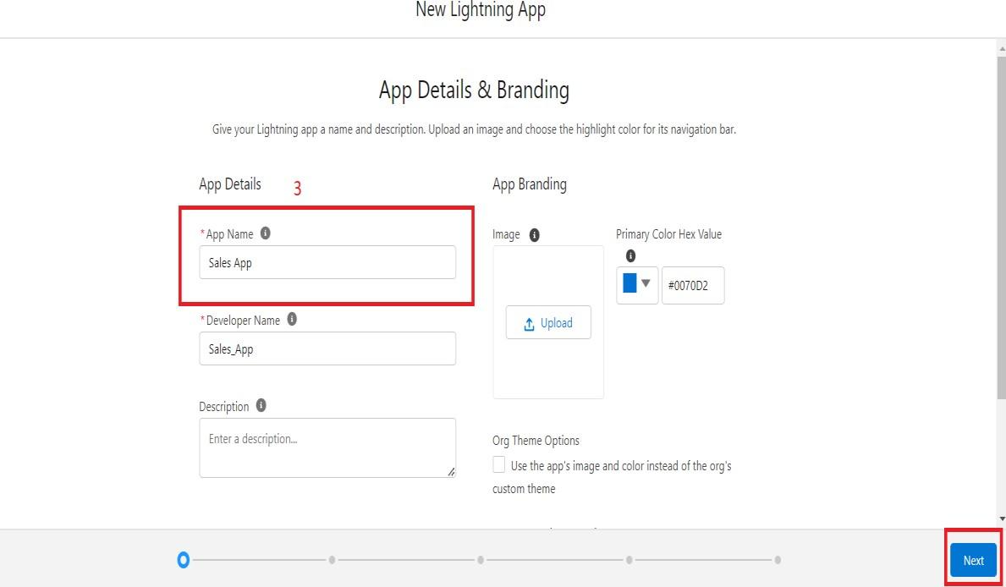

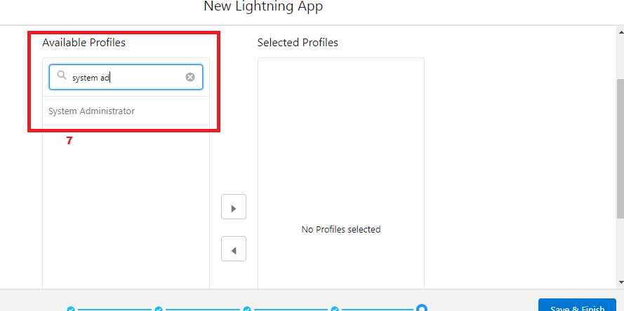

  
  
Note – Similarly create **Service App.**

**Fields And Relationship**

**Fields** -  Fields store data values that are required for a particular object in a record.

An object relationship in Salesforce is **a two-way association between two objects.** Relationships are created by creating custom relationship fields on an object. This is done so that when users view records, they can also see and access related data.

These are fields and their data types we need to create make them one by one –

|  |  |  |
| --- | --- | --- |
| **Object** | **Fields** | **Datatype** |
| Contact | Account website | Lookup (Cross Object Formula field) |
| Warehouse | Address | Text Area |
|  | Location | Text (50) |
| Sales Order | Status | Picklist |
|  | Customer | Lookup (Account) |
|  | Contact | Lookup (contact) |
|  | Order date | Date |
| Dispatch/Tracking | Dispatched | Checkbox |
|  | Tracking ID | Text |
|  | Sales Order | Master Detail (Sales Order) |
|  | Expected date of delivery | Date |

**Creation Of Fields For The Dispatch/Tracking Object**

1. Click the gear icon and select Setup. This launches Setup in a new tab.
2. Click the Object Manager tab next to Home.
3. Select Dispatch/Tracking
4. Select Fields & Relationships from the left navigation
5. Click New
6. Select the Text as the Data Type, click Next.
7. For Field Label, enter Tracking ID & length = 40.
8. Click Next, Next, then Save & New.

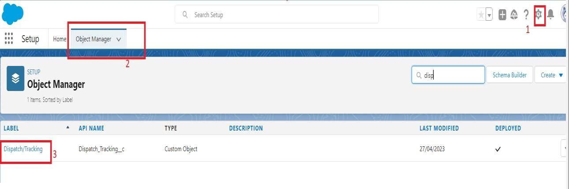  
  
  
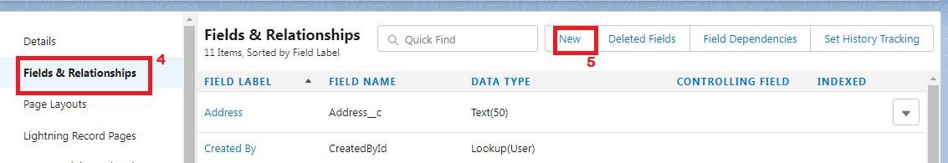  
  
  
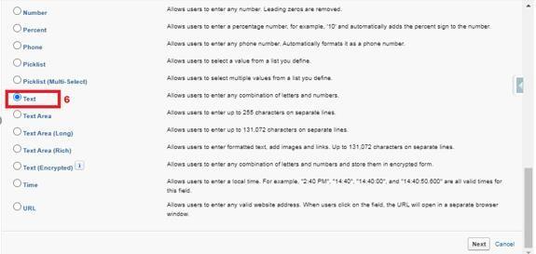  
  
  
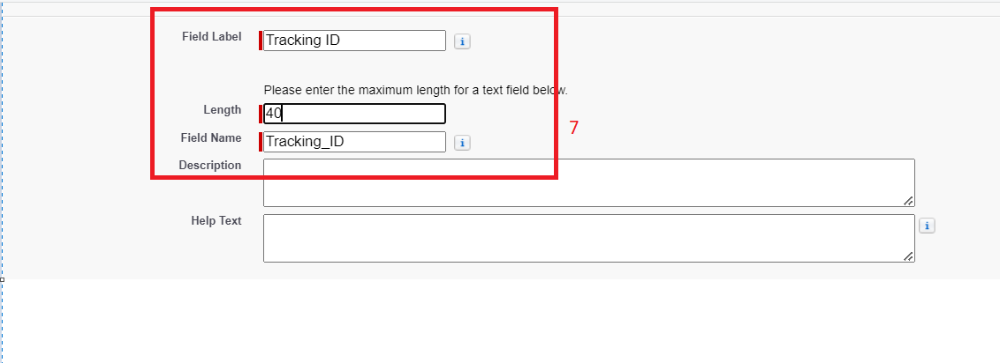  
  
Now let's create the other fields and **we must choose the data types of the fields carefully**. Let’s have a look at it.

Similarly create fields for **Warehouse**object- Address, Location select datatype according table.

Similarly create fields for **Dispatch/Delivery** object- Dispatched, Expected date of delivery select datatype according table.

**Create A Master-Detail Relationship On Dispatch/Delivery Object**

Follow steps 1 to 5 of field creation then follow below steps.

1. Select Master-Detail Relationship as the Data Type and click Next.
2. For Related to, enter Sales order.
3. Click Next.
4. For Field Label, enter Sales order.
5. Click Next, Next, Next and Save.

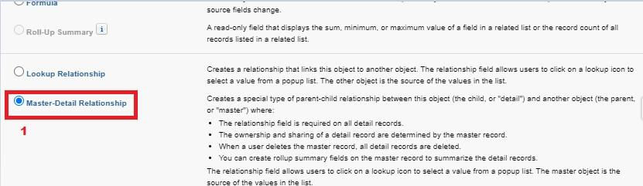  
  
  
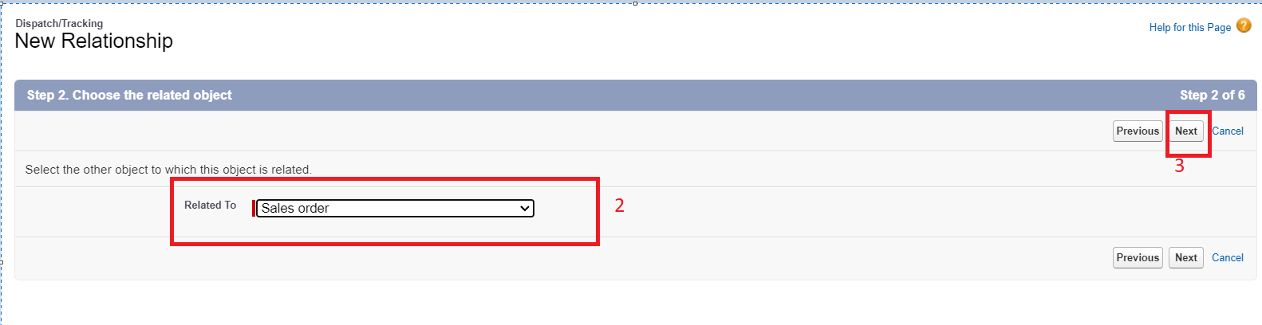  
  
  
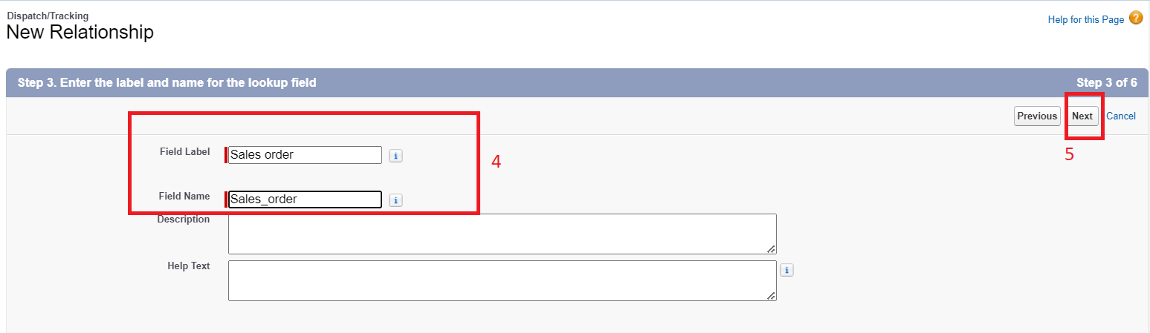

**Create A Pick-List Field On Sales Order**

1. From Setup, click Object Manager and select Sales order.
2. Click Fields & Relationships, then New.
3. Select Picklist as the Data Type and click Next.
4. For Field Label enter Status
5. Select Enter values, with each value separated by a new line and enter these values:
6. Open
7. Hold
8. Shipped
9. Returned
10. Click Next, Next, then Save & New.

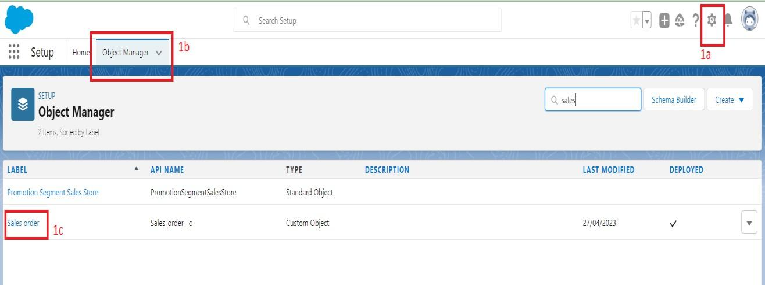  
  
  
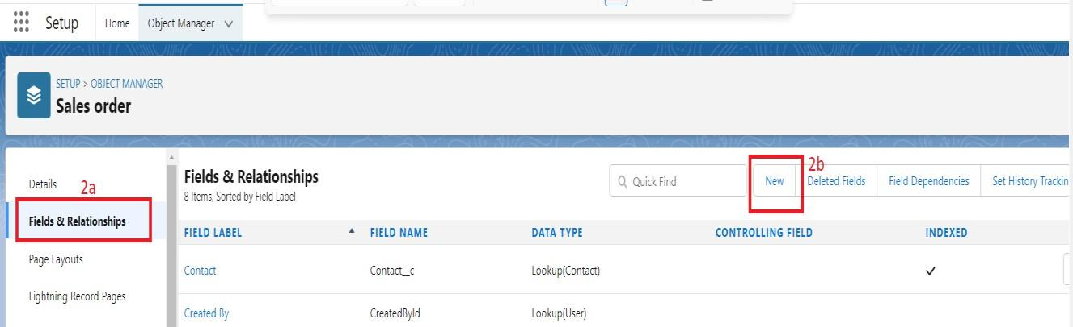  
  
  
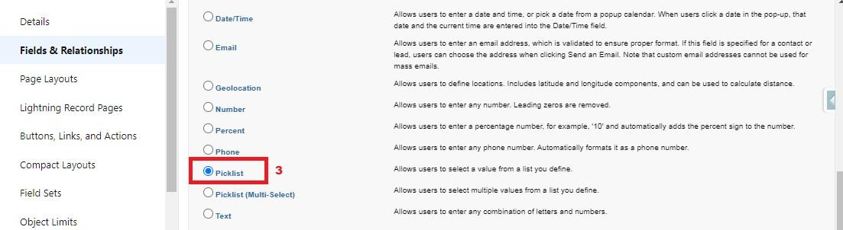  
  
  
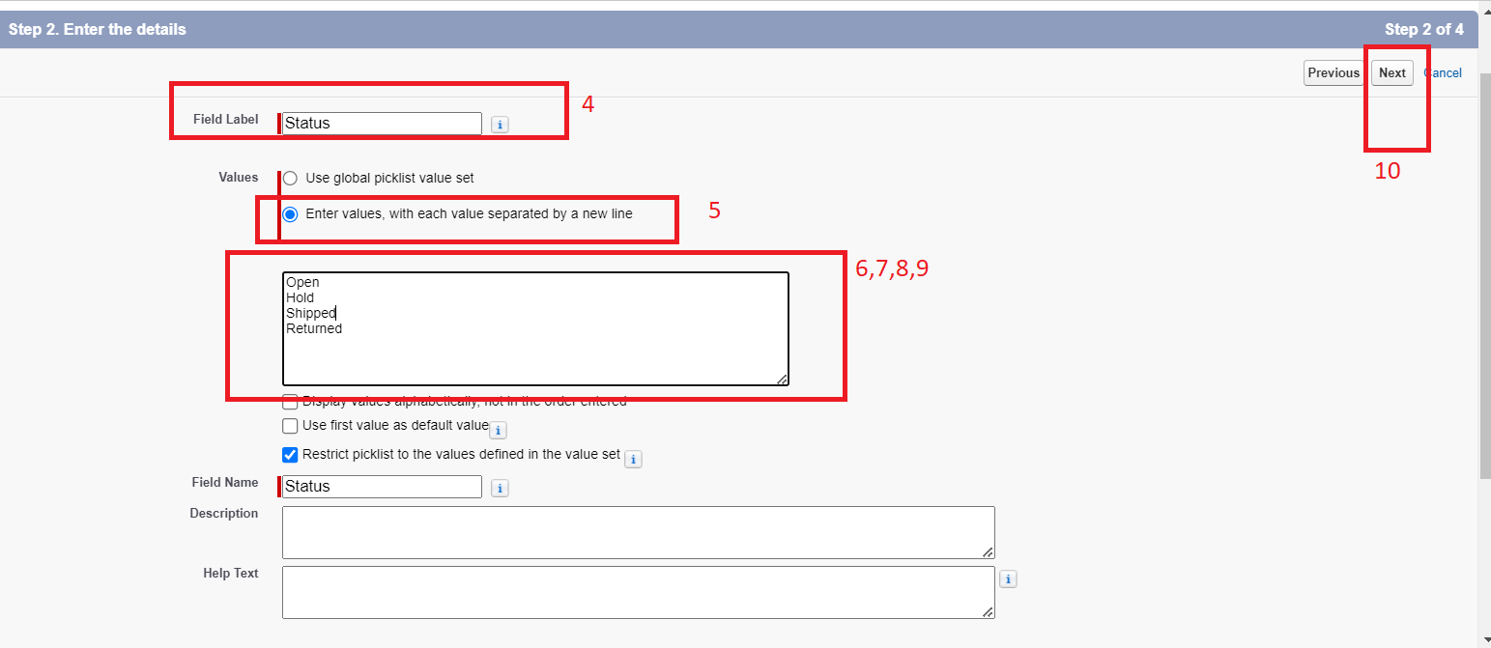

**Create A Lookup Relationship On Sales Order Object With Account Object**

1. Follow steps 1 to 5 of field creation then follow below steps.
2. Select look up Relationship as the Data Type and click Next.
3. For Related to, enter Account.
4. Click Next.
5. For Field Label, enter Customer.
6. Click Next, Next, Next and Save.

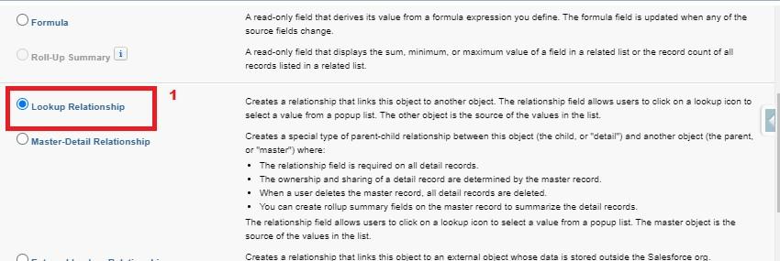  
  
  
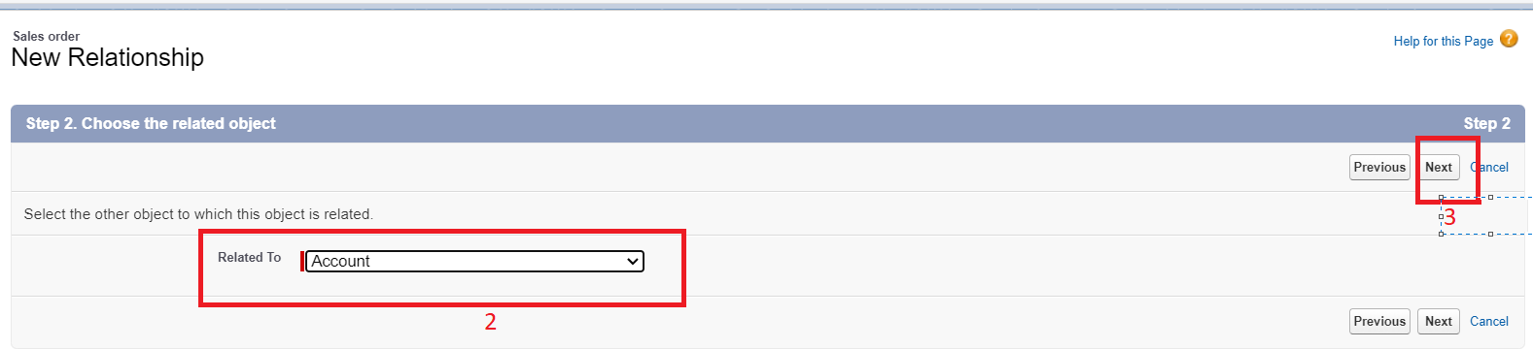  
  
  
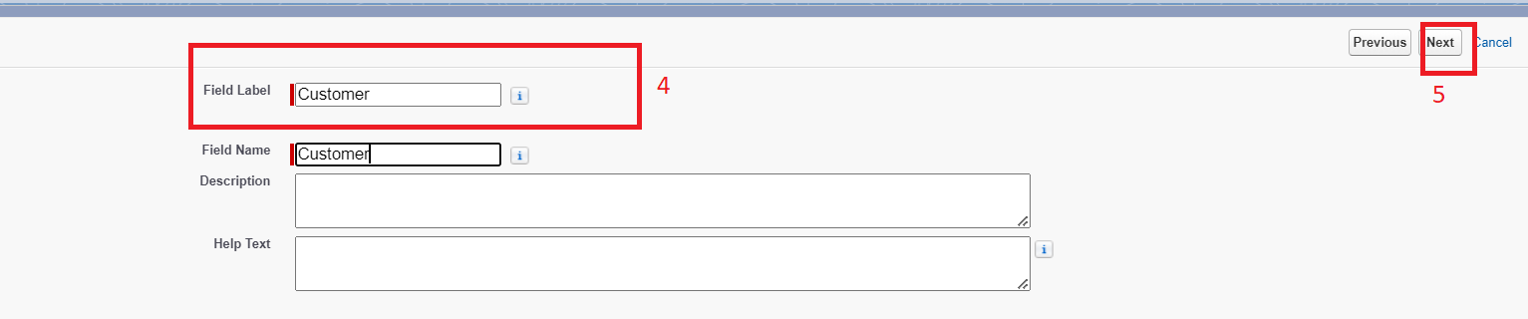  
  
  
**Note**-  Similarly create one more lookup field- Field Name - Contact

                                                                            Related to - Contact

### Create A Lookup Relationship On Sales Order Object With Contact Object With Use Of Lookup Filter.

**Lookup Filter**- Lookup filters limit the records available in the lookup. A lookup filter can reference other fields on the same record (source); fields on the records of the lookup object (target); fields on the user's record, profile, and role; and fields on records directly related to the target object.  
  
Follow steps 1 to 5 of field creation from activity 1 then follow below steps.

1. Select look up Relationship as the Data Type and click Next.
2. For Related to, enter **Contact**.
3. Click Next.
4. For Field Label, enter **Contact**.
5. Click **lookup filter**.
6. Provide filter as given below & also refer picture (Screenshot of Step 6)   
   **Contact: Account ID equals Sales Order: Customer**
7. Click Next, Next, Next and Save.

  
  
  
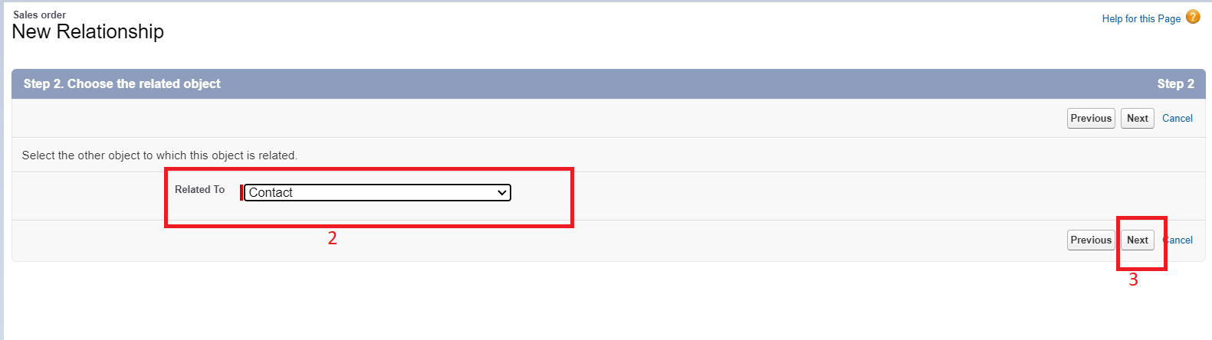  
  
  
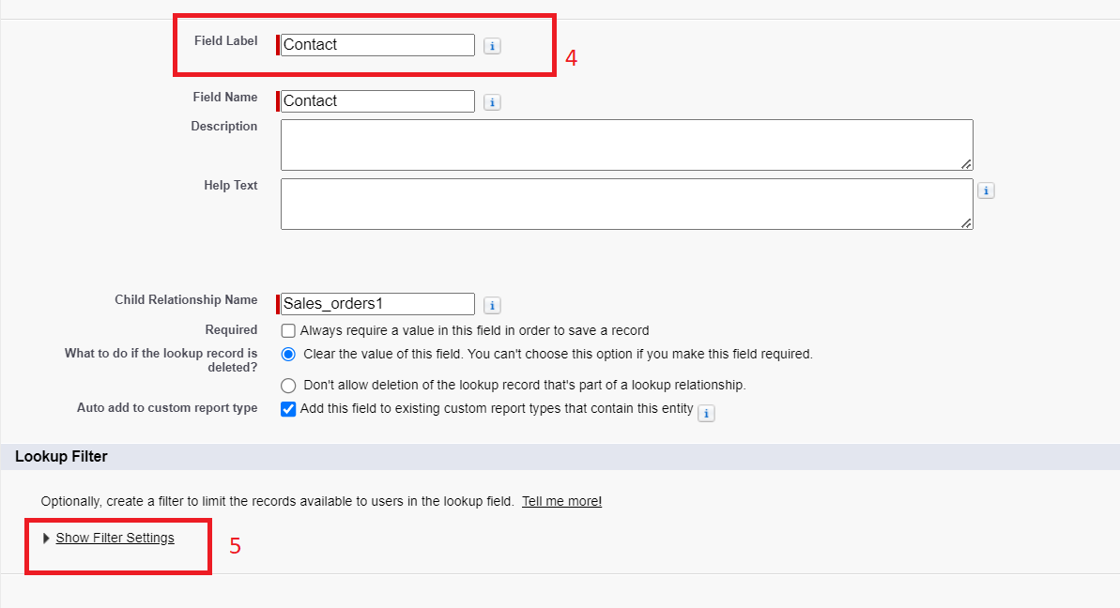  
  
  
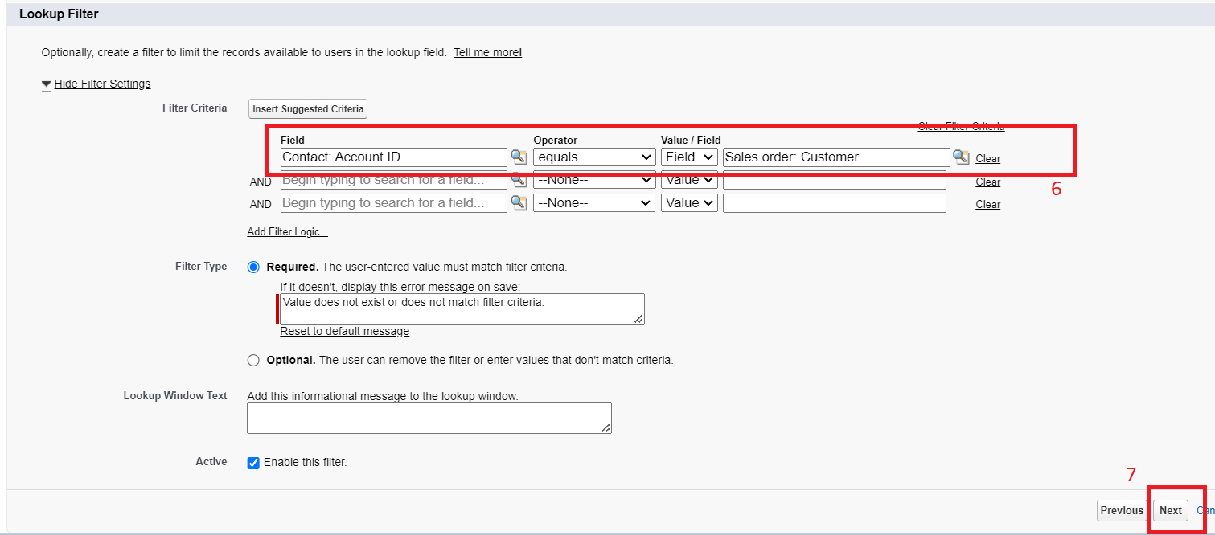

**Create Order Date Field On Sales Order**

1. Click the gear icon and select Setup. This launches Setup in a new tab.
2. Click the Object Manager tab next to Home.
3. Select Sales Order
4. Select Fields & Relationships from the left navigation
5. Click New
6. Select the Date as the Data Type, click Next.
7. For Field Label, enter Order date.
8. Click Next, Next, then Save & New.

  
  
  
  
  
  
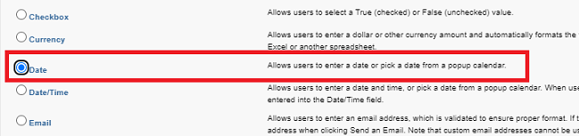  
  
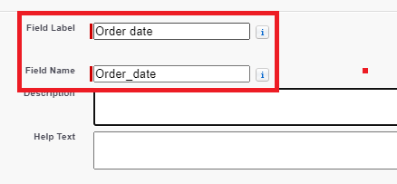

**Cross-Object Formula Field**

A cross-object formula field is basically a formula field.  
A cross-object formula can reference merge fields from a master (“parent”) object if an object is on the detail side of a master-detail relationship.  
A cross-object formula works with Lookup relationships as well as in Master detail relationship. You can reference fields from objects that are up to 10 relationships away.

Creation of cross object formula field-

1. Select your object from object selection has Contact.
2. And select the option fields and relationships.  
   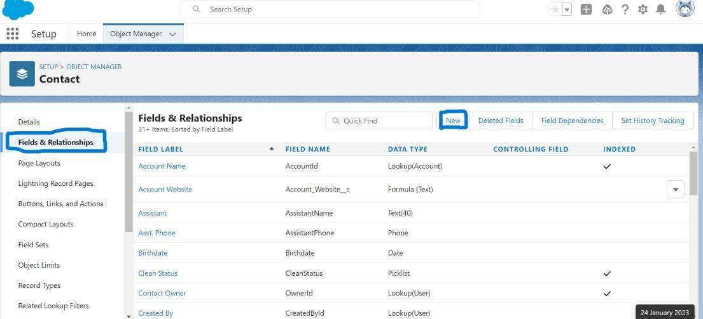
3. At the top right side you can find a new select that option.
4. Now you have to select data type as **formula**.  
   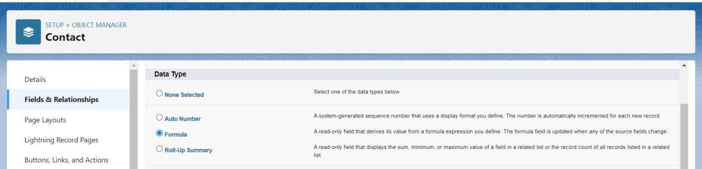
5. And you will navigate to enter the details page where you give the field label.
6. And give the label name has Account Website
7. Select formula return type **Text**
8. In the formula field enter this formula Account. Website.  
   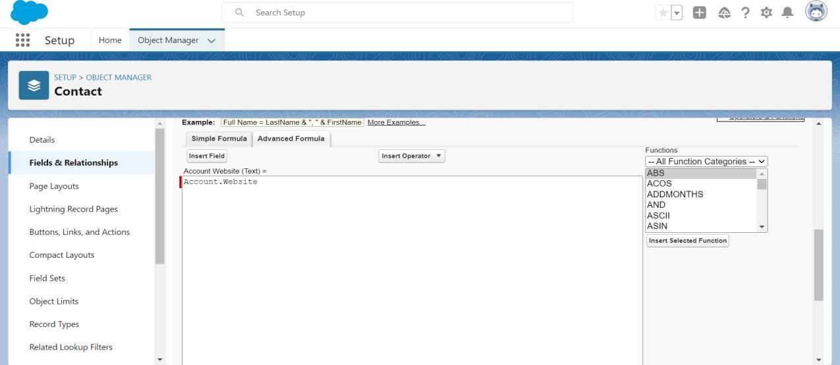  
     
     
   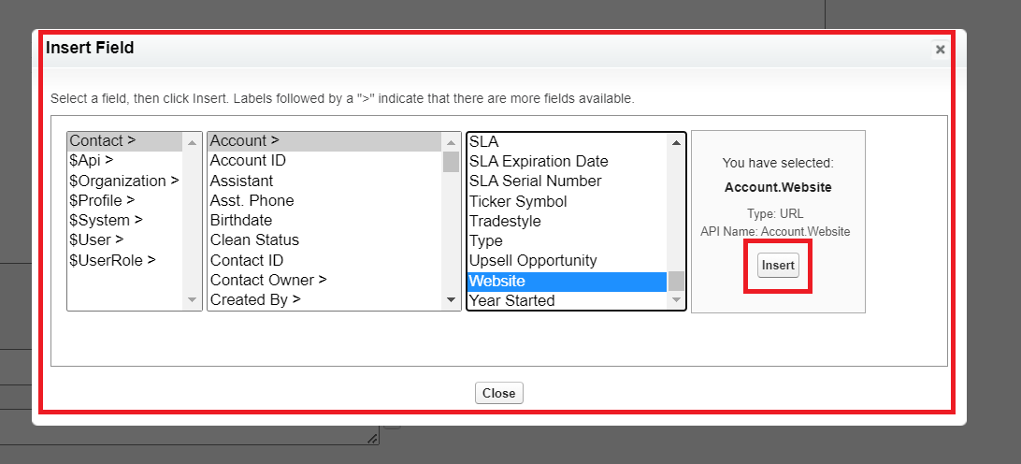
9. Click next you will navigate to field level security click on visible checkbox so that it is visible to all profiles.
10. Select the next option, select the page layout and save it.  
      
    **Note**– Give a help text while creating Location filed on Warehouse Object.  
    Help Text- **To locate product in Warehouse.**

**User**

A user is **anyone who logs in to Salesforce**. Users are employees at your company, such as sales reps, managers, and IT specialists, who need access to the company's records. Every user in Salesforce has a user account.

**Creating A User**

1. From Setup, in the Quick Find box, enter Users.
2. Select Users.
3. Click New User.  
     
   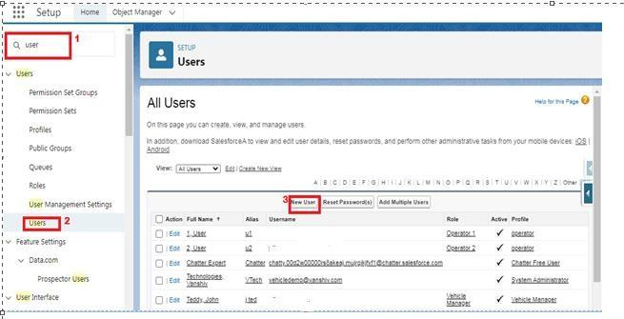
4. Enter the First Name and Last Name manager and (Your) email address and a unique username in the form of an email address. By default, the username is the same as the email address.
5. Select a User License as Salesforce
6. Select Standard User profile.  
     
   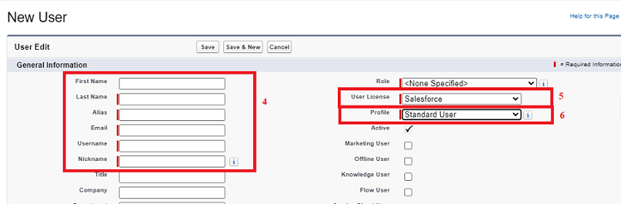
7. Check Generate new password and notify the user immediately to have the user’s login name and a temporary password emailed to your email.

**Validation Rules**

Validation rules verify that the data a user enters in a record meets the standards you specify before the user can save the record. As a crm product owner they requested to create a validation rule on account object on the phone field.

### Creation Of Validation Rule

1. Navigate to object manager and select Account object.
2. In details section scroll down and find validation rule in it.  
     
   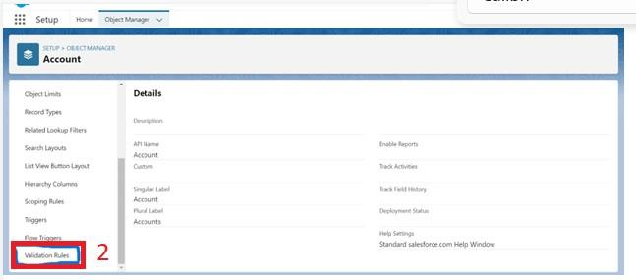
3. Click new, give the label name and in edit error conditional formula give the formula  
   - LEFT(Phone, 1) <> "+" .
4. And in error message give the description has Phone number must begin with + (country code).
5. In error location select field.  
   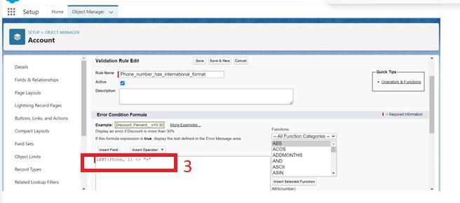  
     
   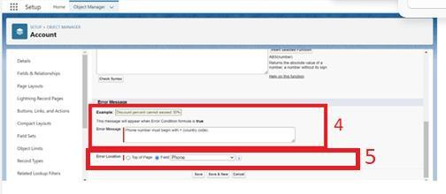
6. Save

### User Adoption

**Create Record (Sales Order)**

1. Click on App Launcher on left side of screen.
2. Search Sales App & click on it.
3. Click on Sales Order tab.
4. Click new button  
     
   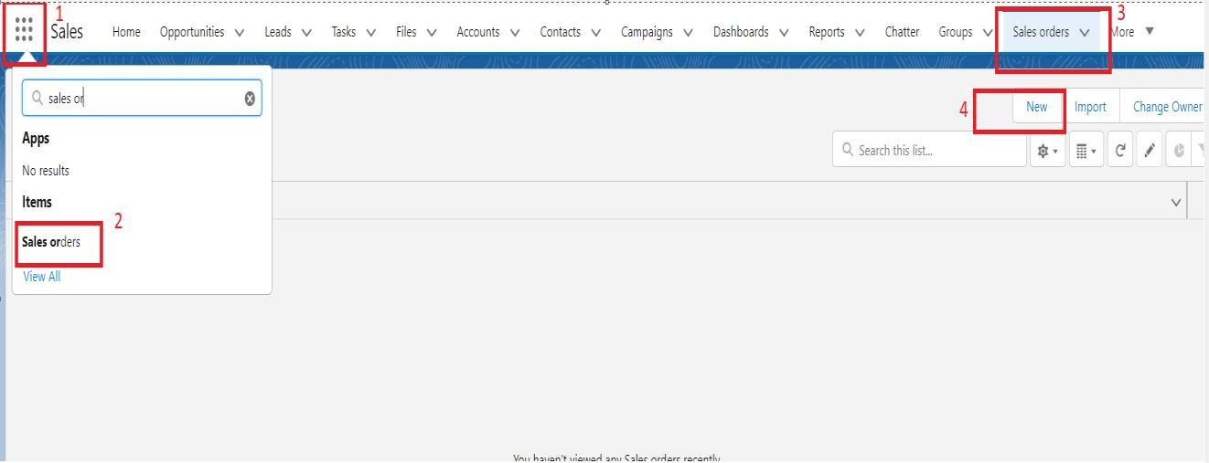
5. Fill all Sales Order record details.
6. Click on Save Button  
     
   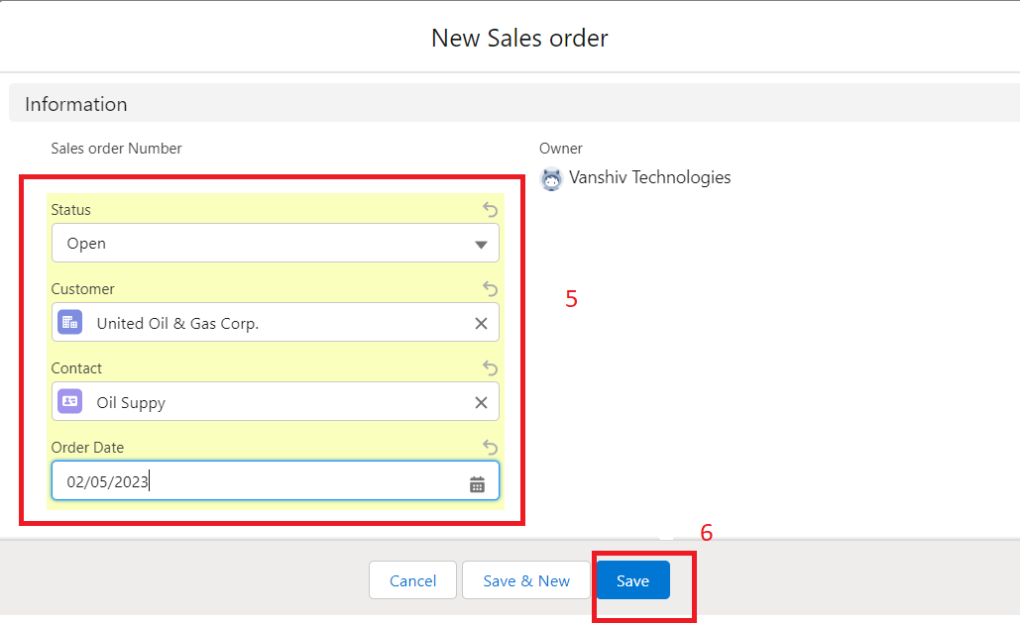

**Note**-Similarly create few records of each object.

**View Record (Sales Order)**

1. Click on App Launcher on left side of screen.
2. Search Sales App & click on it.  
     
   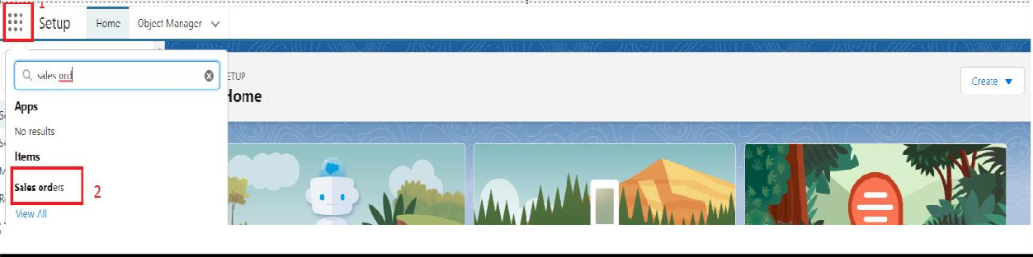
3. Click on Sales Order Tab.
4. Click on any record name. you can see the details of the Sales Order  
     
   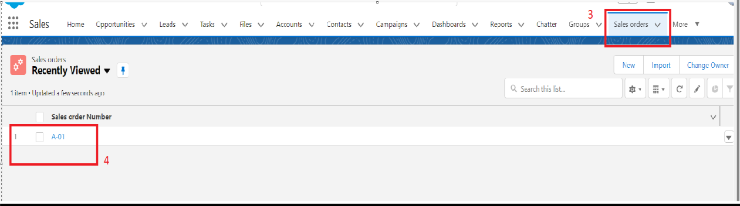

**Delete Record (Sales Order)**

1. Click on App Launcher on left side of screen.
2. Search Sales App & click on it.  
     
   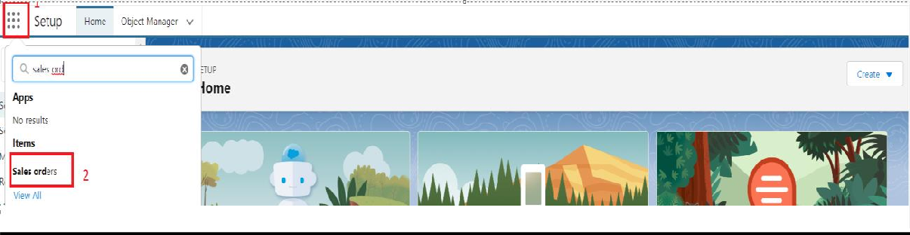
3. Click on Sales Order Tab.
4. Click on Arrow at right hand side on that Particular record.
5. Click delete and delete again.  
     
   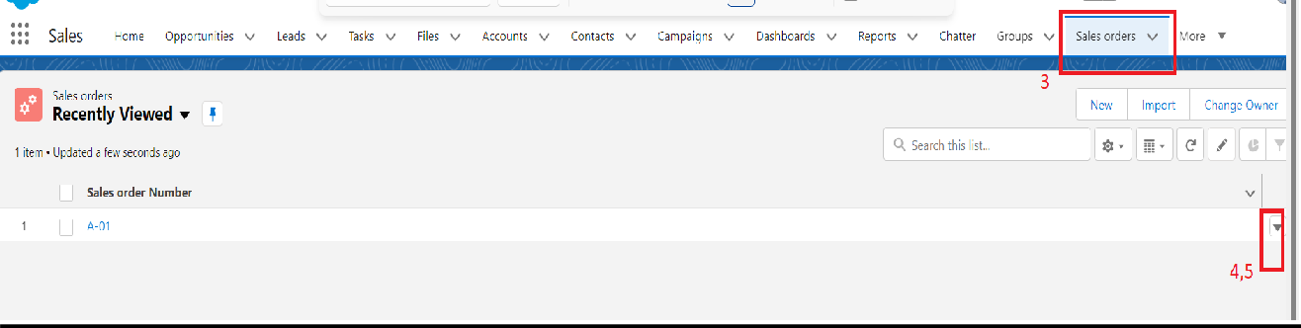

**Reports**

Reports in Salesforce is a list of records that meet a particular criterion which gives an answer to a particular question. These records are displayed as a table that can be filtered or grouped based on any field.  
  
  
There are 4 types of report formats in Salesforce:

1. Tabular Reports:  
   This is the most basic report format. It just displays the row of records in a table with a grand total. While easy to set up they can’t be used to create groups of data or charts and also cannot be used in Dashboards. They are mainly used to generate a simple list or a list with a grand total.
2. Summary Reports:  
   It is the most commonly used type of report. It allows grouping of rows of data, view subtotal, and create charts.
3. Matrix Report:  
   It is the most complex report format. Matrix report summarizes information in a grid format. It allows records to be grouped by both columns and rows. It can also be used to generate dashboards. Charts can be added to this type of report.
4. Joined Reports:  
   These types of reports let us create different views of data from multiple report types. The data is joined reports are organized in blocks. Each block acts as a subreport with its own fields, columns, sorting, and filtering. They are used to group and show data from multiple report types in different views.

Report types:  
Report type determines which set of records will be available in a report. Every report is based on a particular report type. The report type is selected first when we create a report. Every report type has a primary object and one or more related objects. All these objects must be linked together either directly or indirectly.

A report type cannot include more than 4 objects.  
Once a report is created its report type cannot be changed.  
  
There are 2 types of report types:

1. Standard Report Types:  
   Standard Report Types are automatically included with standard objects and also with custom objects where “Allow Reports” is checked.  
     
   [Standard report types](https://help.salesforce.com/articleView?id=standard_report_folders.htm&type=5)cannot be customized and automatically include standard and custom fields for each object within the report type. Standard report types get created when an object is created, also when a relationship is created.  
     
   Note: Standard report types always have inner joins.
2. Custom Report Types:  
   Custom report types are reporting templates created to streamline the reporting process. Custom Reports are created by an administrator or User with “Manage Custom Report Types” permission. Custom report types are created when standard report types cannot specify which records will be available on reports.  
     
   In custom report types we can specify objects which will be available in a particular report. The primary object must have a relationship with other objects present in a report type either directly or indirectly.

There are 3 types of access levels of folders:

1. Viewer:  
   With this access level, users can see the data in a report but cannot make any changes except cloning it into a new report.
2. Editor:  
   With this access level, users can view and modify the reports it contains and can also move them to/from any other folders they have access level as Editor or Manager.
3. Manager:  
   With this access level, users can do everything Viewers & Editors can do, plus they can also control other user’s access levels to this folder. Also, users with Manager Access levels can delete the report.  
   From this milestone we are going to import the data and create the reports and dashboards for datavisualization in the application

**Create Report**

1. Click App Launcher and
2. Select Sales App  
     
   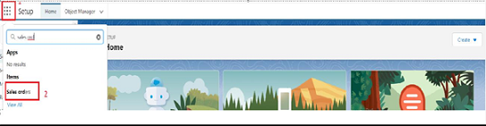
3. Click reports tab
4. Click New Report.  
     
   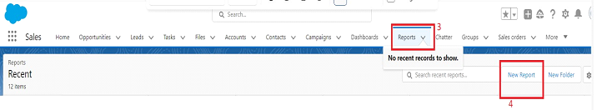
5. Click the report type as Sales order with customer Click Start report.  
     
   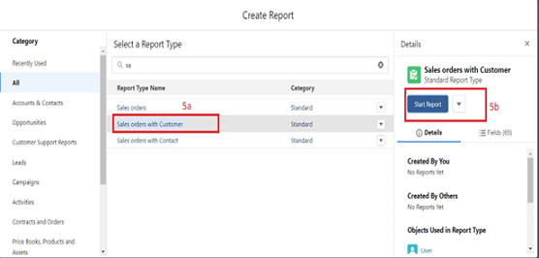
6. Customize your report, in group rows select - Customer Account Name
7. Click refresh
8. Click save and run  
     
   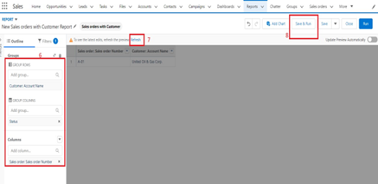
9. Give report name – New Sales orders with Customer Report
10. Click Save  
      
    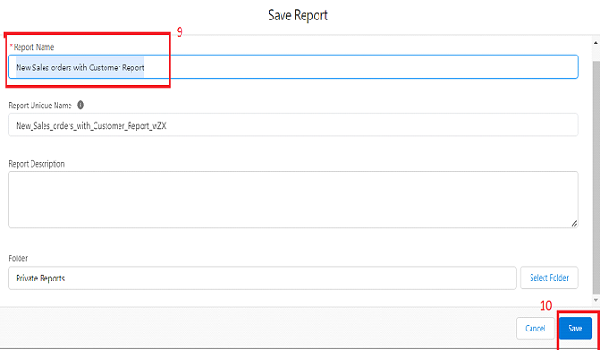

**View Report**

1. Click on App Launcher on left side of screen.
2. Search “Sales App” & click on it.  
     
   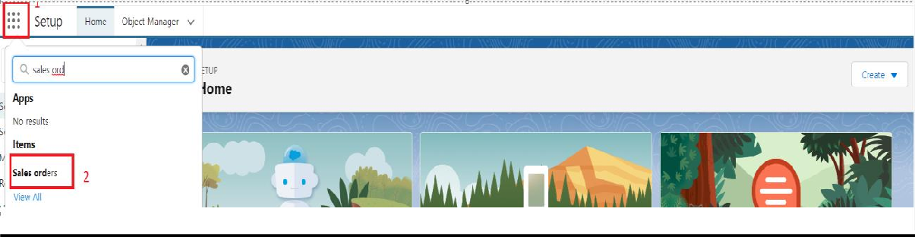
3. Click on Reports Tab.
4. Click on New Sales orders with Customer Report and see records.  
     
   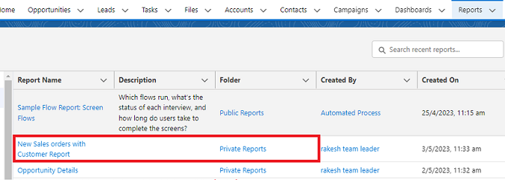

**Dashboards**

Dashboards **let you curate data from reports using charts, tables, and metrics**. If your colleagues need more information, then they're able to view your dashboard's data-supplying reports. Dashboard filters make it easy for users to apply different data perspectives to a single dashboard.

**Create Dashboard**

1. Click on Dashboards tab from the “Sales App” application,
2. Click on new dashboard  
     
   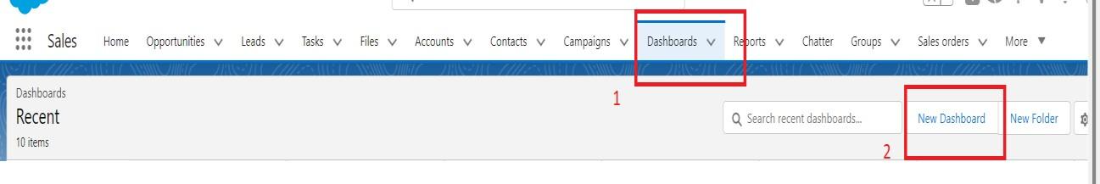
3. Give name- Sales App Dashboard
4. Click create  
     
   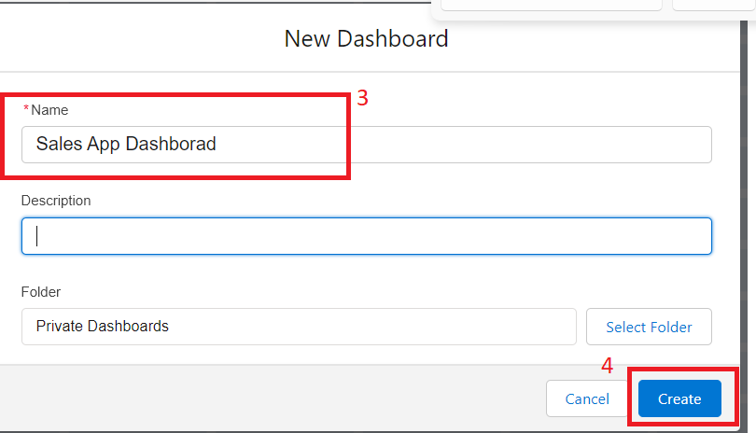
5. Give your dashboard a name and click on +component.  
     
   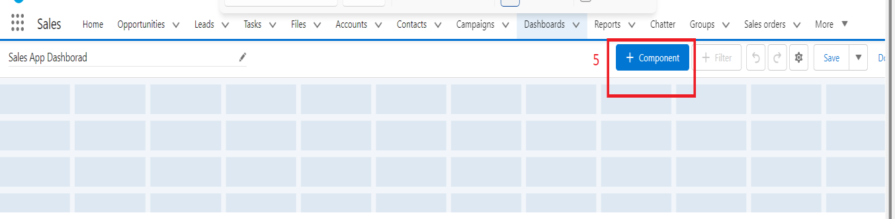
6. Select the New Sales orders with Customer Report which you created.  
     
   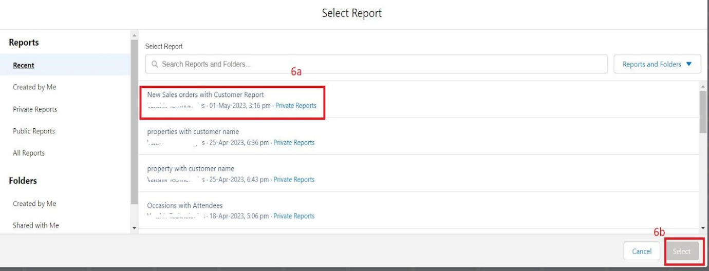
7. For the data visualization select any of the chart, table etc as your wish.
8. Click add  
     
   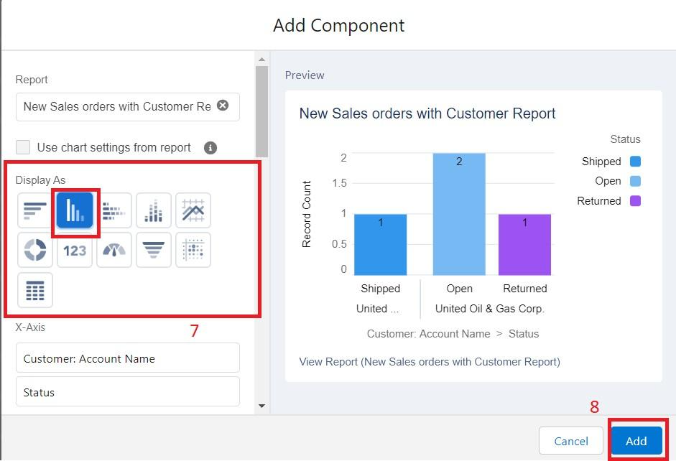
9. Click save  
     
   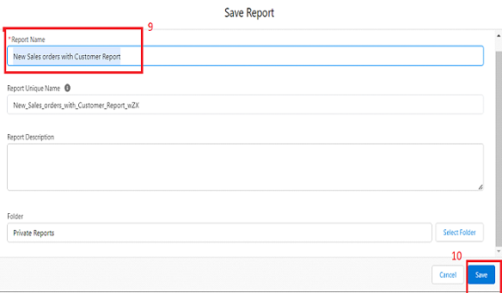

**View Dashboard**

1. Click on App Launcher on left side of screen.
2. Search Sales App & click on it.  
     
   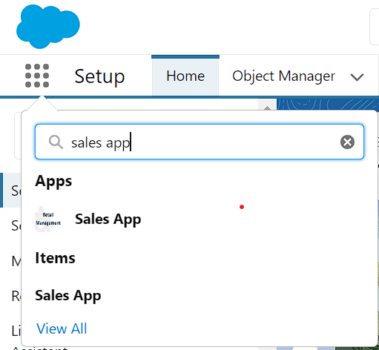
3. Click on Dashboard Tab.
4. Click on Sales App Dashboard and see graph view of records  
     
   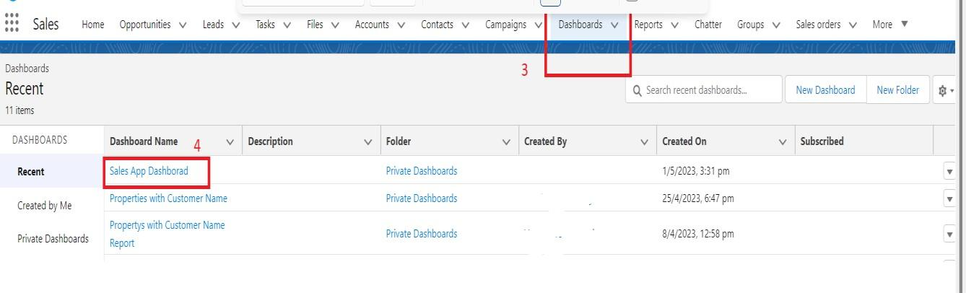

**Flows**

Flows are an automation tool provided by Salesforce which can be used to perform various tasks like, Sending an Email, Posting a chatter, Sending custom Notifications &, etc. Flow is the most powerful automation tool provided by Salesforce. It can be trigger for record insert, update and record delete and it can be run for both after and before events.

**Create Flow**

* Click on setup gear

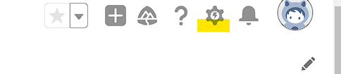    

* In quick find search for Flows
* Choose new flow option at right side of the page

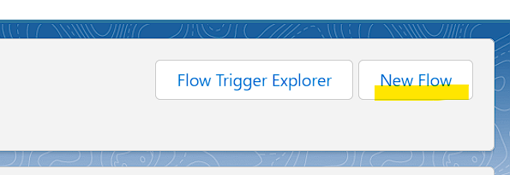

* Now select screen flow as a new flow

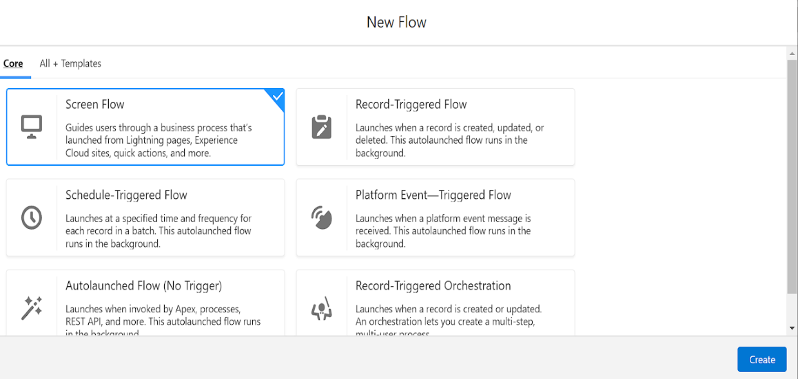

1. Left side corner of the page you can find a toggle click on that and select a new resource.

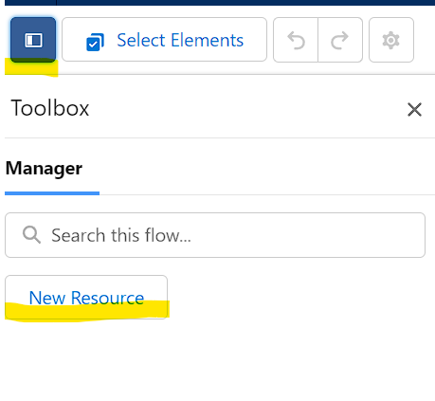

1. and select resource type has variable
2. Give api name as Recordid
3. and select data type as Text
4. At bottom for  Availability outside the flow check the box as Available for Input
5. Click on done

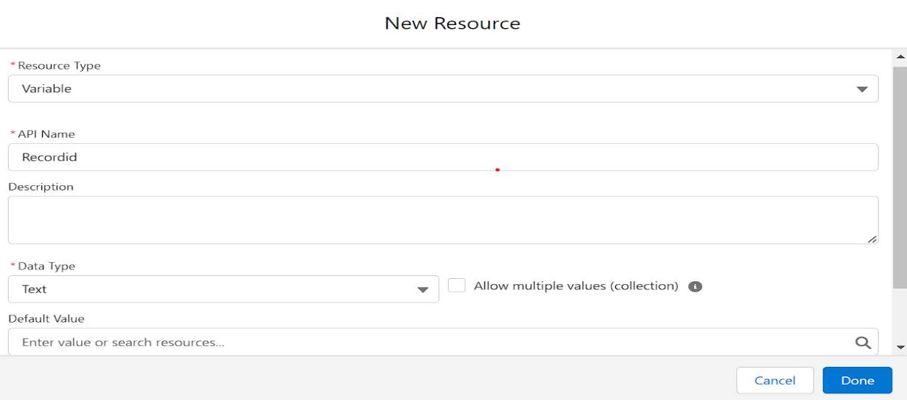

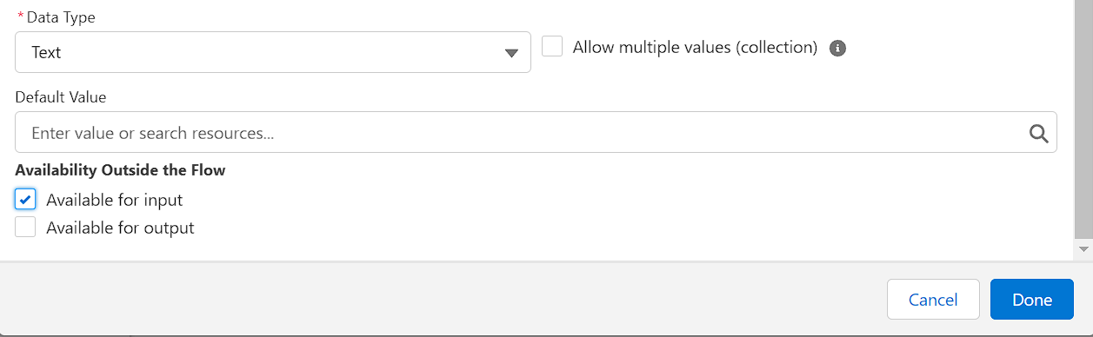

               7.  Now below the start button click on add element and choose Get Records

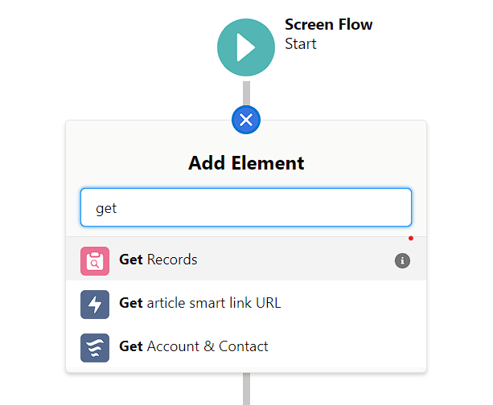

* Now give the label name as Get Account Record
* For Get record of object choose object as - Account
* For Filter account records condition requirements are - All conditions are met
* Field- Account id     Operator- equals     Value- Recordid (variable which we had created )
* For how many records to share - Only the first record
* How to store record data- Automatically stores all fields.
* Click on done.

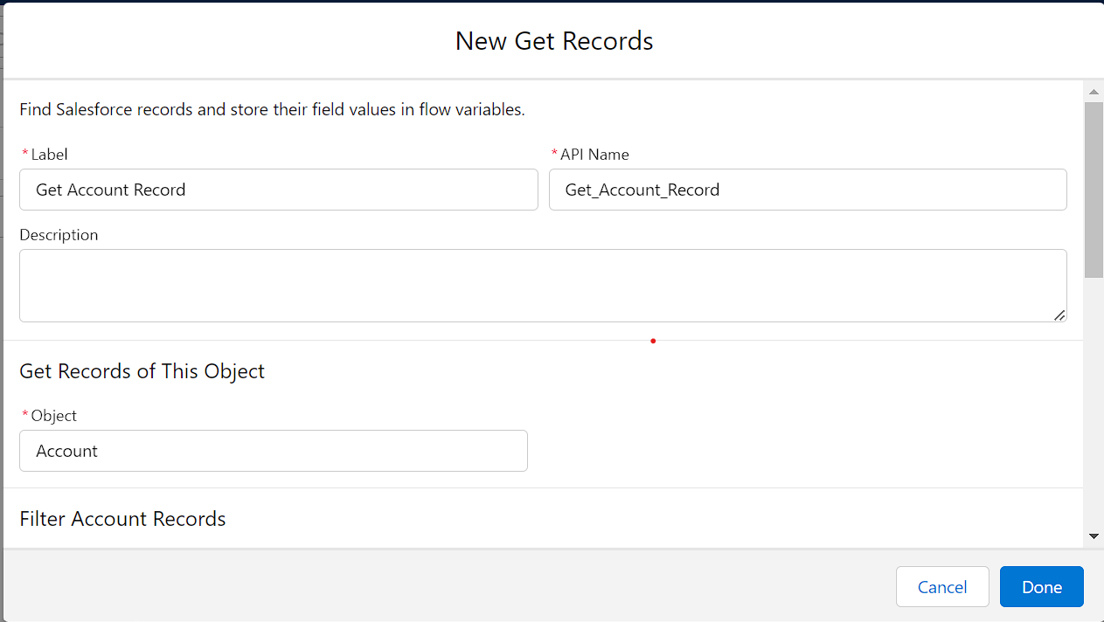

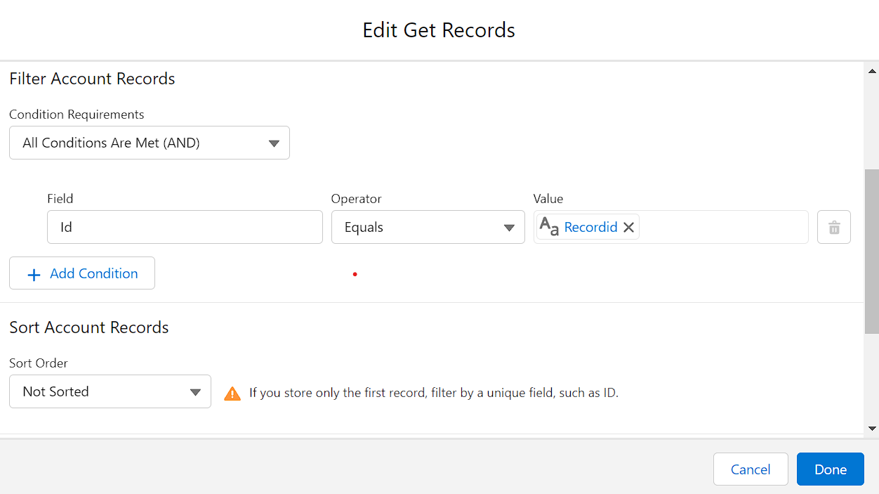

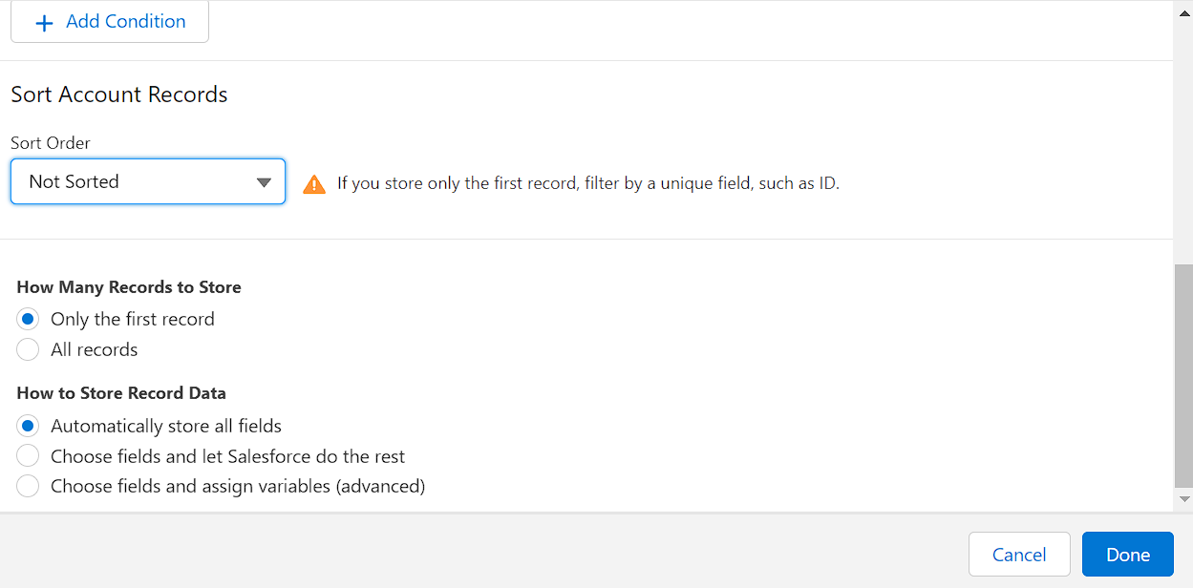

* Now again add the element below the Get account record and select Screen as your element

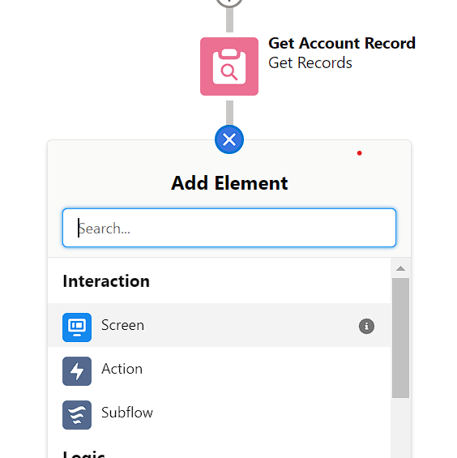

* Give the label name as Get Account & Contact

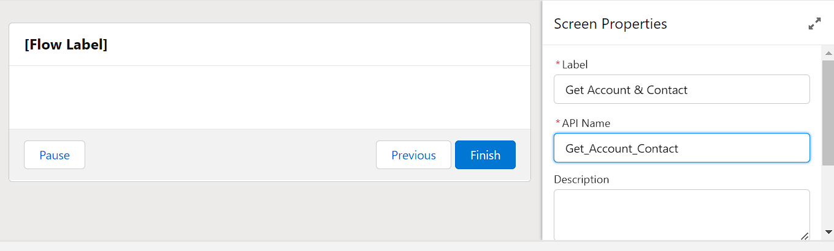

* Left side in the component section search for Name and drag it to the screen
* Give the api name as Name

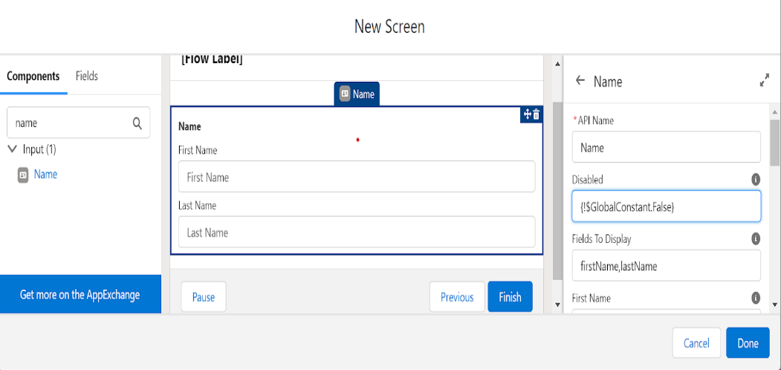

* Now drag Email from component section and move it to the screen
* Give the Api name- Email
* Required - {!$GlobalConstant.True}

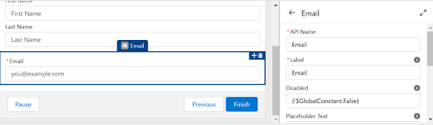

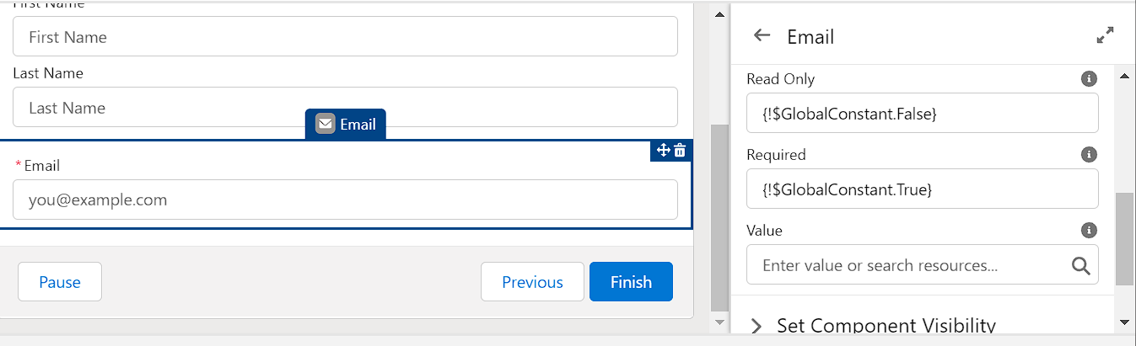

1. Now drag the Phone from component to screen below the email
2. Give the Api name as - Phone
3. Required- {!$GlobalConstant.True}

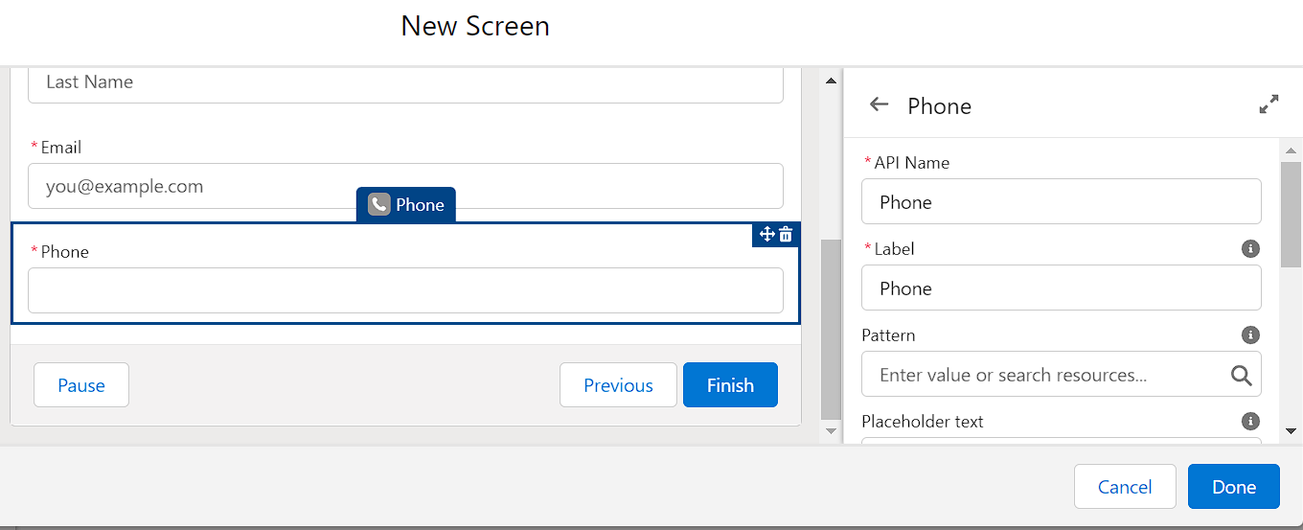

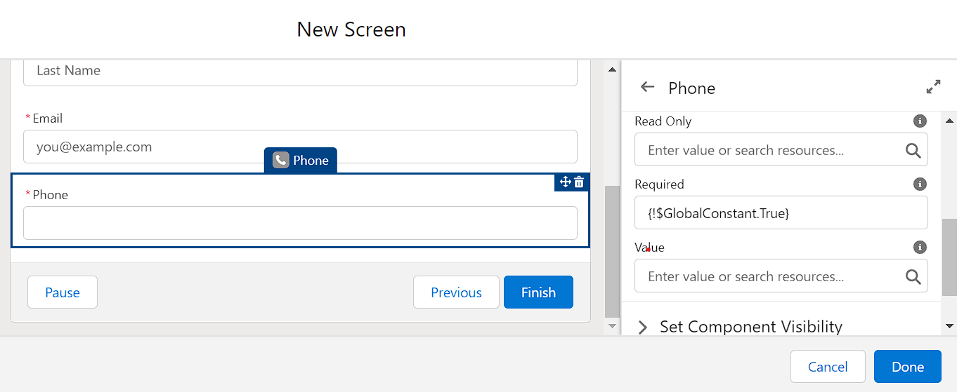

1. Now Drag Address from component section to screen
2. Give the Api name as - Address

             City Value- {!Get_Account_Record.ShippingCity}

             Country Value- {!Get_Account_Record.BillingCountry}

             Postal code- {!Get_Account_Record.ShippingPostalCode}

             State/province value- {!Get_Account_Record.ShippingState}

             Street Value- {!Get_Account_Record.ShippingStreet}

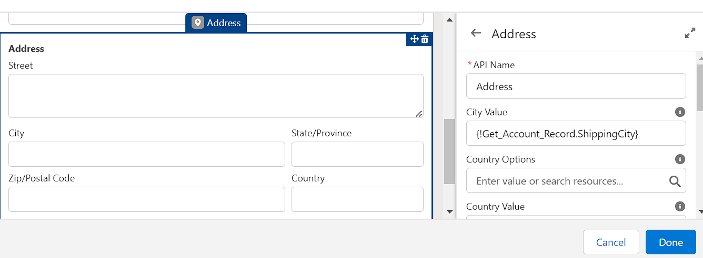

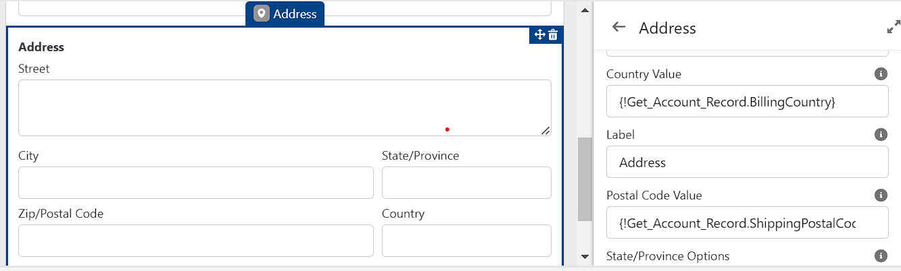

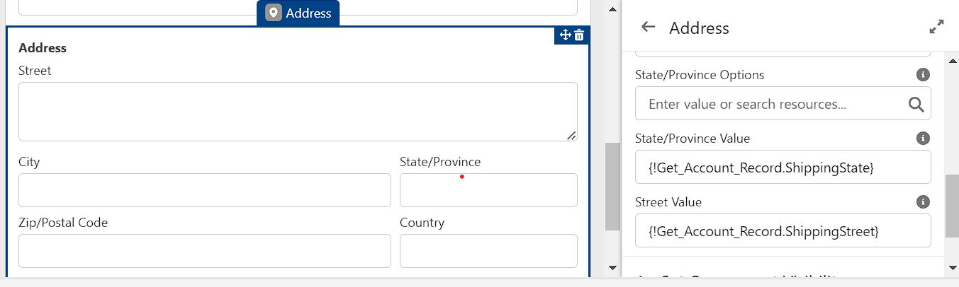

* Click on done and save it. Give the label name as Get Account & Contact.

**To Create Lightning Home Page**

1. Click on setup gear.
2. Now search for lightning App builder.
3. And select New option
4. In create a new lightning page select Home page.

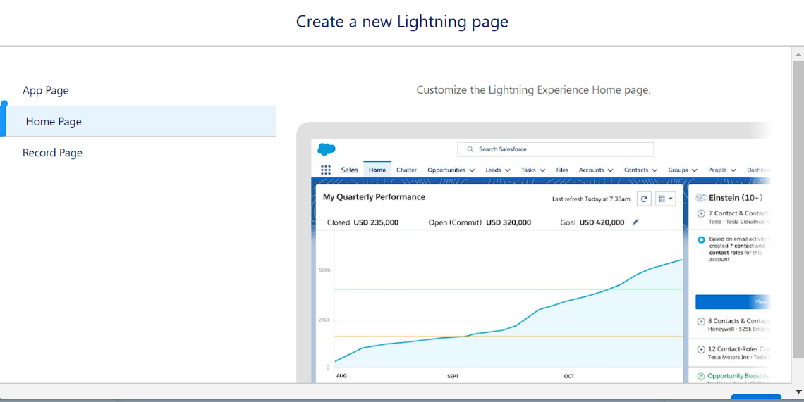

1. Select Next
2. Give the label name - Account & Contact
3. Choose a standard home page.
4. Now in the component section select flow and drag down it to Corner of the page.

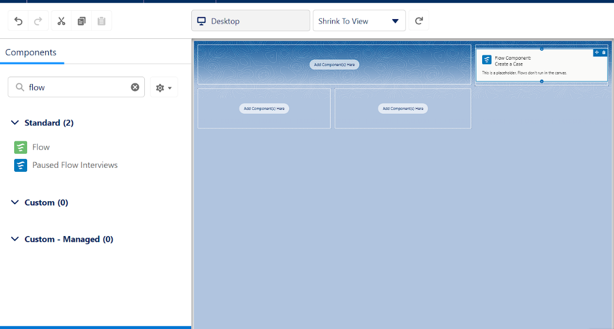

1. At the right side select the flow Get Account & Contact

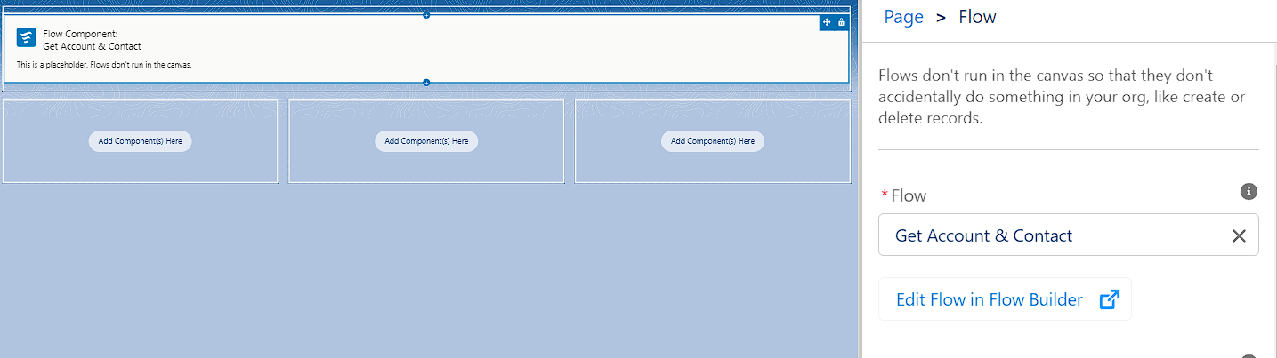

1. at the right side top of the page click on Save.
2. You will get the populate notification and click on activate.

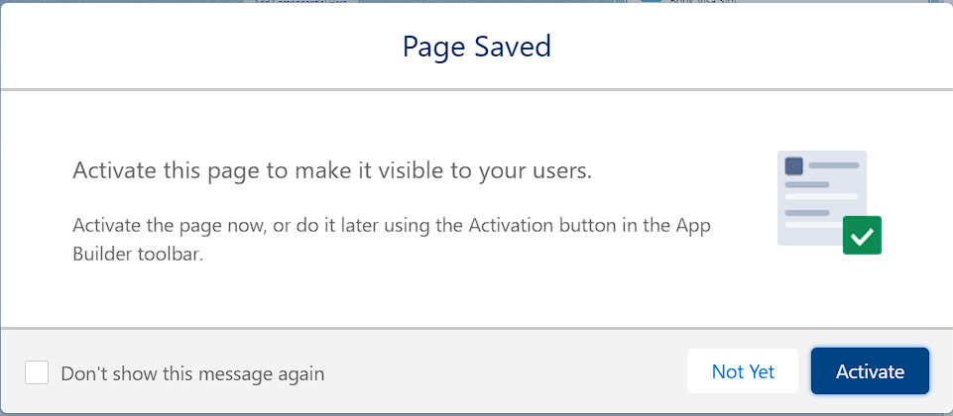

1. you will get an activation pop up select App and profile.

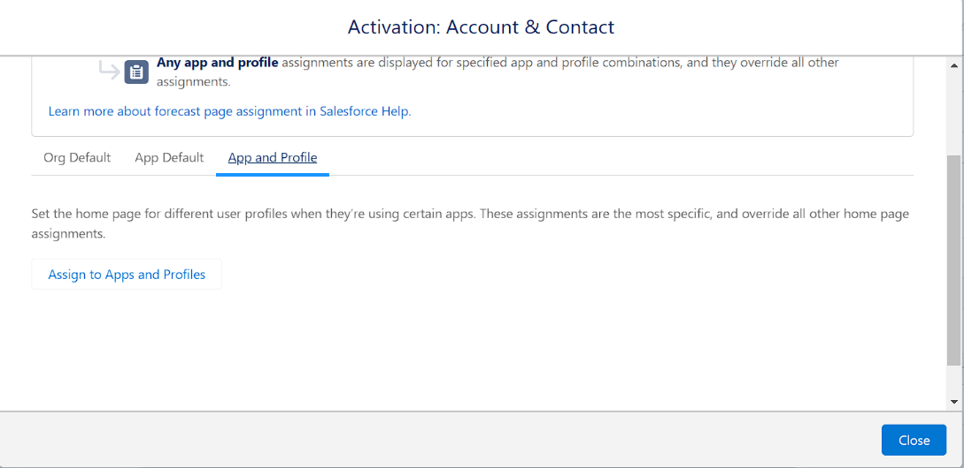

1. Select Sales app in lightning app selection.
2. In profiles select System administrator, Standard user, Standard platform user.
3. Save it.

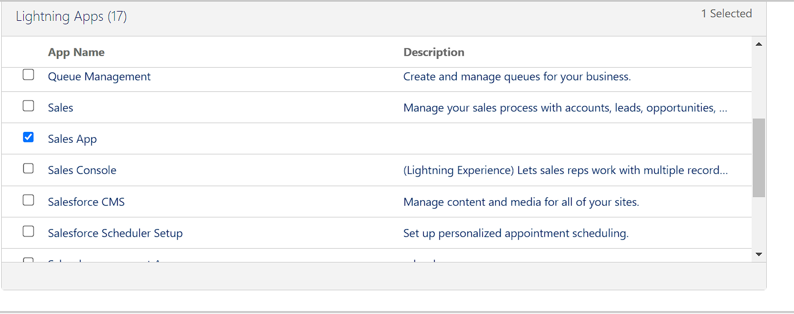

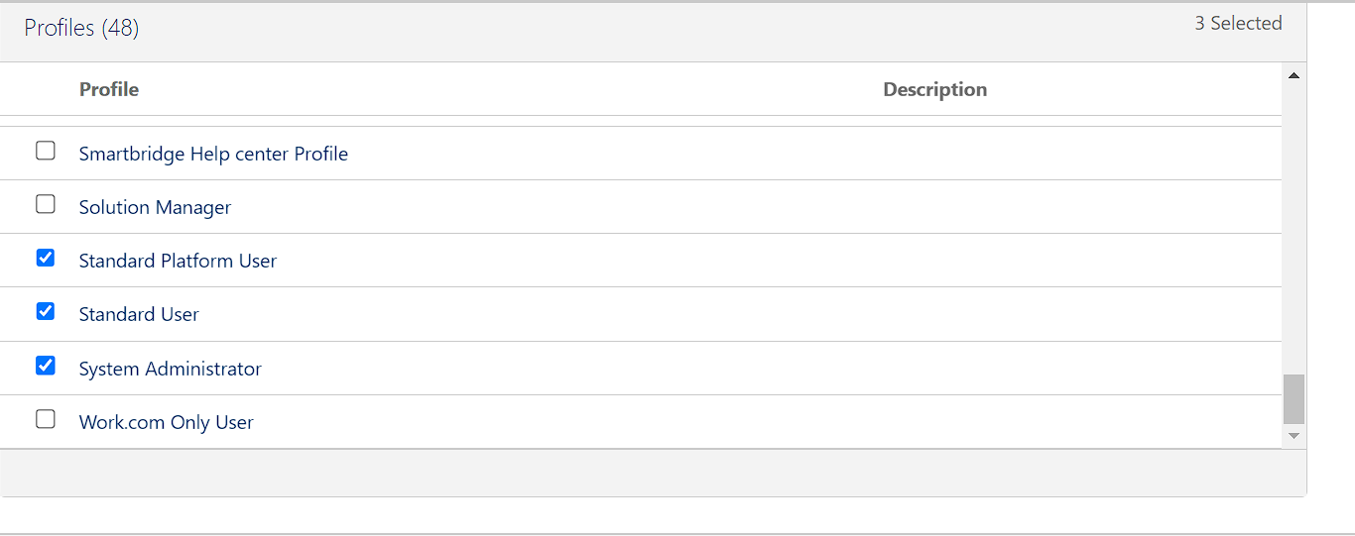

1. Now click on app launcher and search for Sales App
2. At the right side corner you can find a Pencil icon to personalize navigation click on that.
3. Click on add more items and in available items click on all and search for home.
4. Move the home page to top and click on save

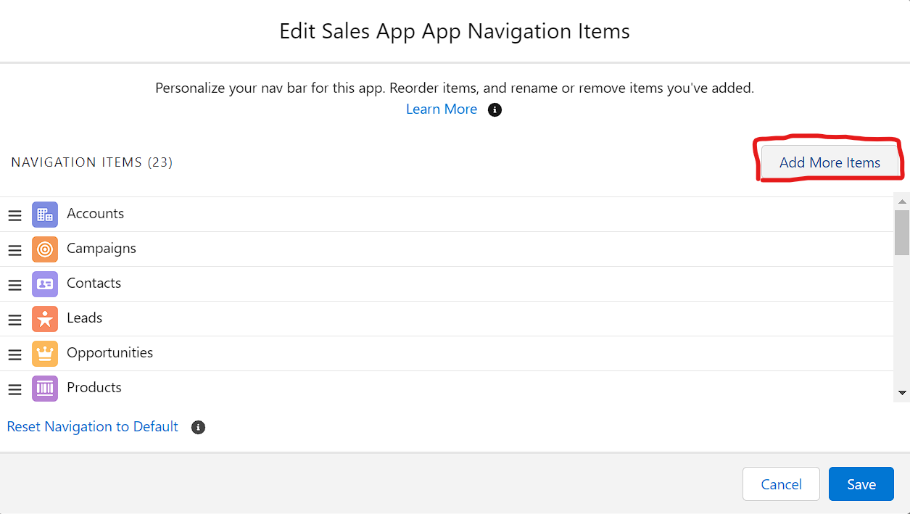

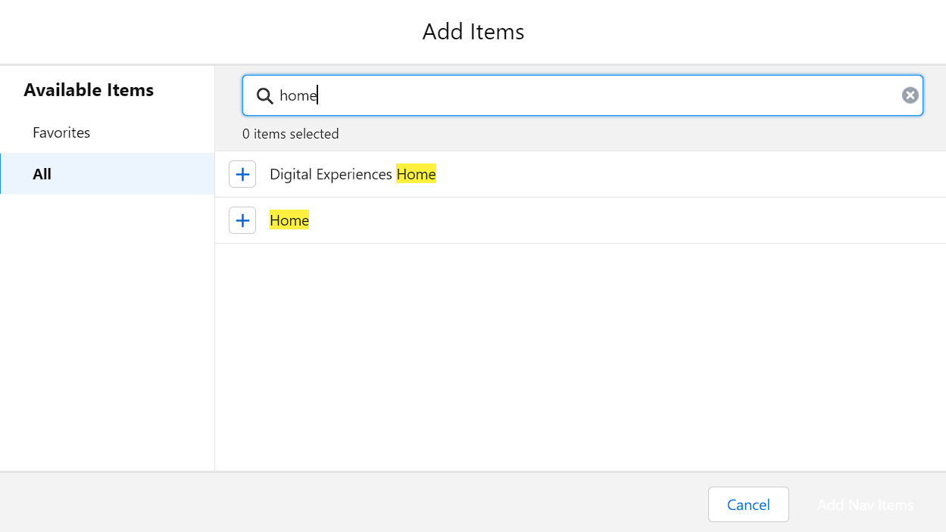

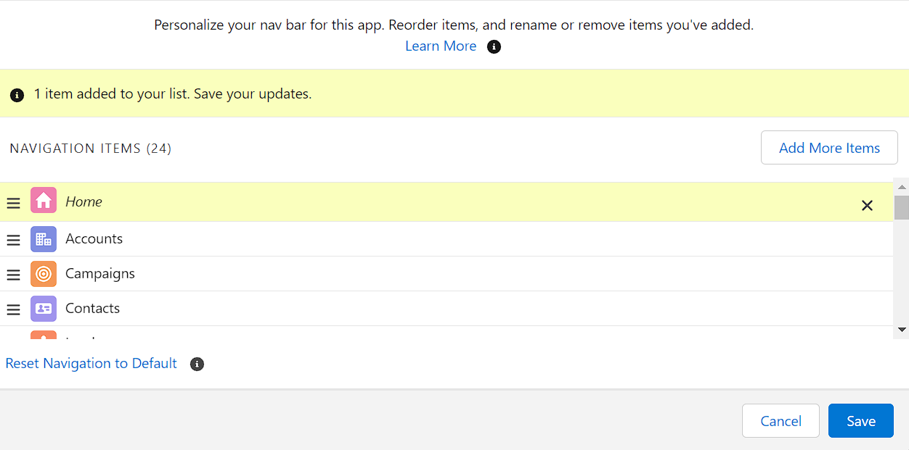

**To Send An Email Alert To The Customer Once Order Is Confirmed**

To send an email alert to the customer once order is confirmed.

1. Navigate to setup click on object manager
2. Select sales order as object
3. click on fields and relationships
4. Select Email id field and click on edit
5. Than in general options  select Required Field
6. Save it.

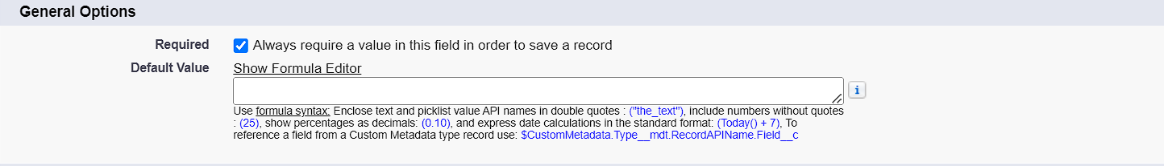

              Now Create a new field Order confirmed

1. On the same object sales order create a Pikclist field.
2. Give the label name as Order confirmed.
3. And in Values give 1) Yes

                               2) No

1. Make it as Required field.

**To Create Record Trigger Flow**

   To create record triggered flow

1. Click on setup and search for flows.
2. Than click on new flow
3. Select Record Trigger flow as your flow
4. In Object search for Sales order
5. In Configure Trigger select A record is created
6. In set entry conditions All conditions are Met
7. In fields search for Order confirmed
8. Operator - Equals
9. In values select - Yes
10. In optimize the flow for Select Action and related Records

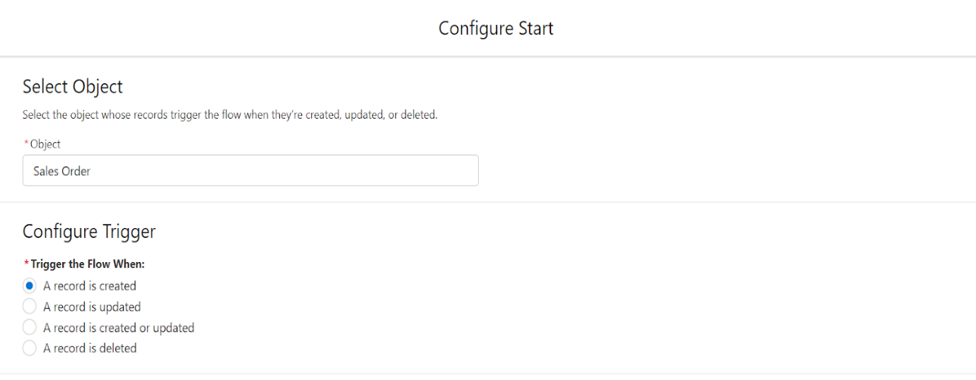

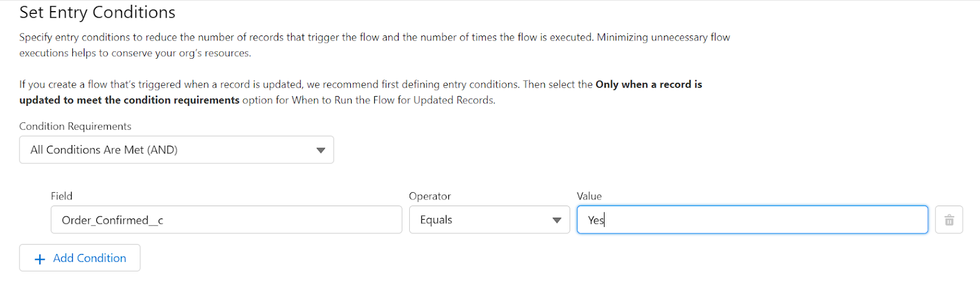

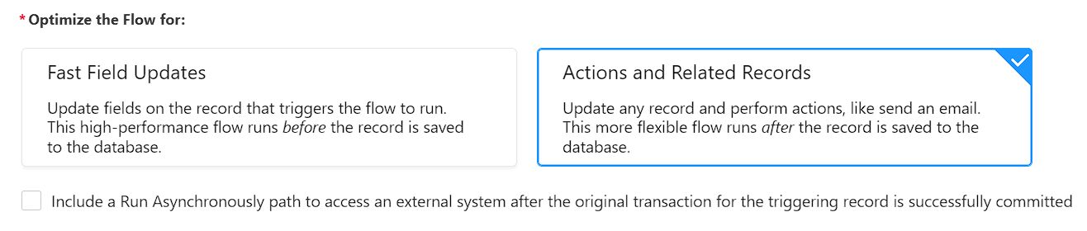

1. Now click on add element and in Logic section select Decision element
2. Give the element name as Is Order confirmed
3. In Outcome Details Label as Order Status
4. In condition requirement All Conditions are Met
5. In resource select $Record than field as Order confirmed
6. Operator - Equals
7. Value as Yes
8. Click on done

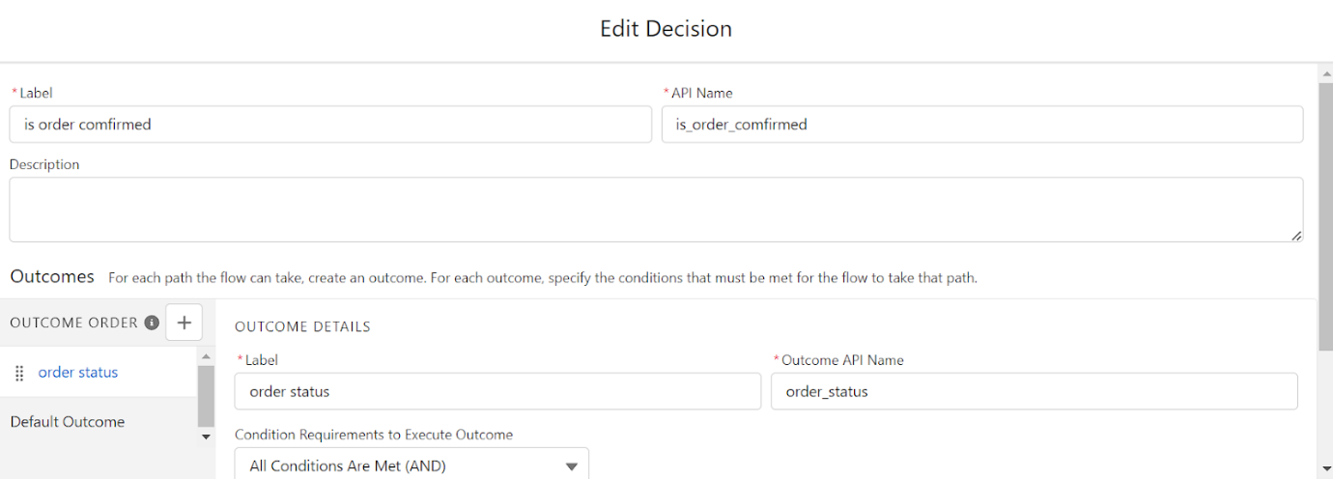

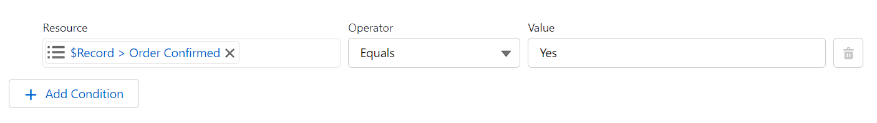

1. Now Below the Order status Click on add element and select Action as your element.

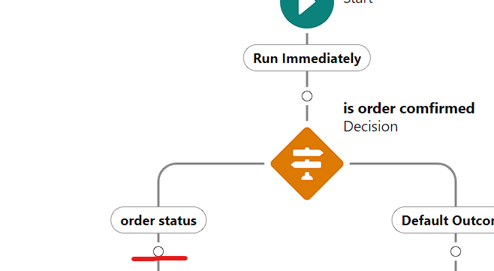

1. Now in action select Send email

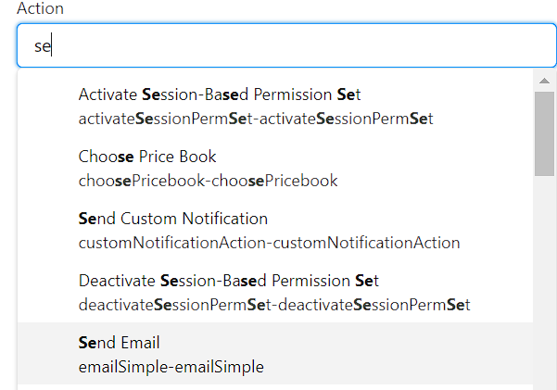

1. Give the label as Send an email to customer
2. Now in body select $Record and than select Id
3. Move your cursor to front before $record and give the text as Hi Your order with than comes $record is confirmed
4. In recipients email address list -  select Record and than Email id as your field
5. In subject give it as - Order confirmed.
6. Click on done.
7. Save the flow as Email to customer
8. And activate the flow.

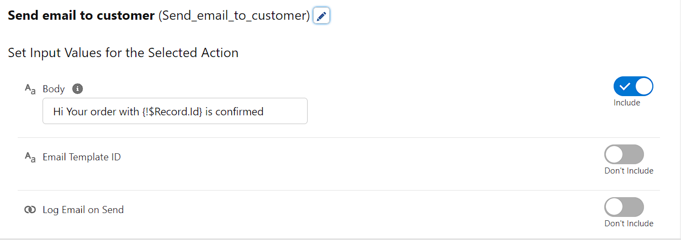

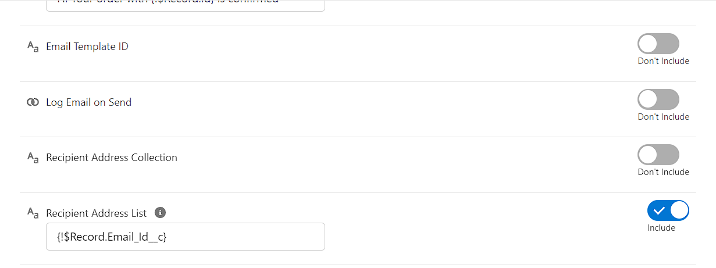

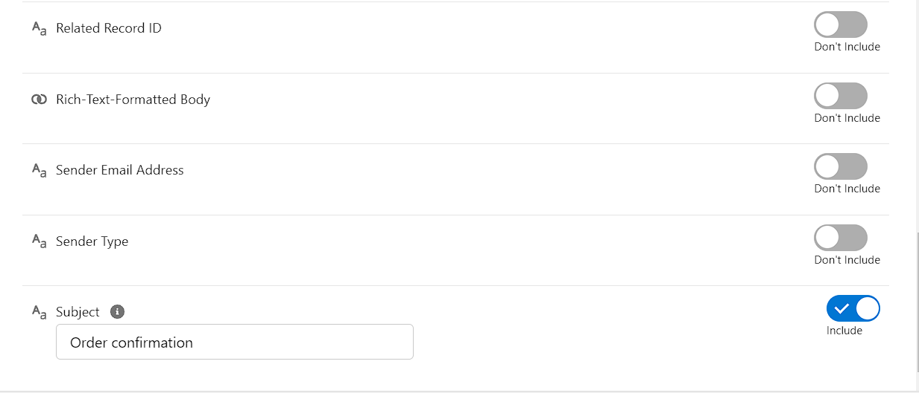

### Triggers

  A Trigger is a segment of Apex code which executes before or after inserting or modifying a Salesforce record based on the  condition provided. There are different types of triggers based on the action going to be performed.

 They are Before Triggers and After Triggers. Triggers allow modification of another record of the same type or different type.

            There are two different types of Apex triggers within Salesforce:  
  
           **“Before” Apex Triggers**. These are used to update or validate the value in a record before you save it to your Salesforce   database.  
  
            “**After” Apex Triggers**. These are used to access the values contained within a record and use that value to make changes to  other records in your Salesforce database. Unlike “Before” triggers, “After” triggers are read-only.

**Trigger On Account To Prevent Duplicate Name**

**Trigger on Account to prevent Duplicate Name.**

               Handler

               1. Click on Setup and select developer console

               2. Click on file and than New

               3. Select Apex Class  give the name as Toavoidduplicateshandler

      public class ToAvoidDuplicateHandler {

     public static void preventDuplicate(list<Account> acclist){

        for (Account a : acclist){

            for (Account a1 : [Select id,name from Account]){

                if(a.name == a1.name){

                    a.name.addError('This is a duplicate name');

                }

            }

        }

    }

}

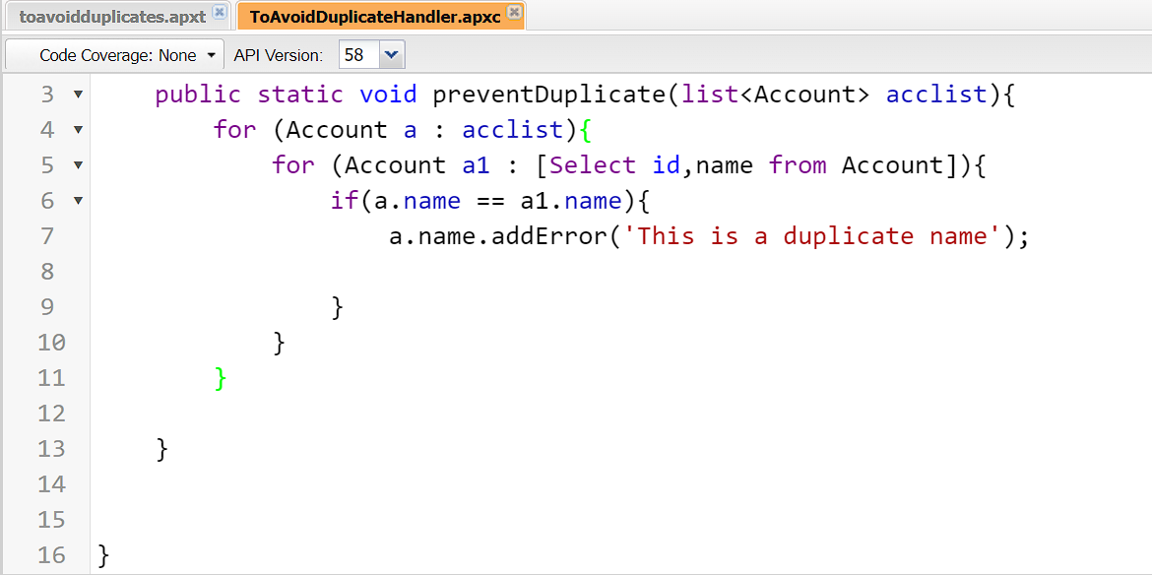

**Trigger**

               1. Click on Setup and select developer console

               2. Click on file and than New

               3. Select Apex trigger give the name as Toavoidduplicates

               4. Sobject as Account.

trigger toavoidduplicates on Account (before insert) {

    if(trigger.isBefore){

        ToAvoidDuplicateHandler.preventDuplicate(trigger.new);

    }

}

